Depth of tree water uptake is related to predictors of drought adaptation across levels of organisation
Authors:
Michèle van Zyl^{1,2}, Matthias Saurer³, Ronny Richter^{1,2}, Johannes Schmidt^{1,4}, Alexandra Weigelt^{1,2} , Max Tölle^{2,5}, Lena Kretz², Anja Kahl² , Heiko Moossen⁶ , Heike Geilmann⁶ and Christian Wirth^{1,2,6}
Corresponding Author Email: micheleth02@gmail.com
Affiliations:
¹German Centre for Integrative Biodiversity Research (iDiv) Halle-­Jena-­Leipzig, Leipzig, Germany
² Systematic Botany and Functional Biodiversity, Leipzig University, Leipzig, Germany
³Forest and Soil Ecology, Swiss Federal Institute for Forest, Snow and Landscape Research, WSL, Birmensdorf, Switzerland
⁴Physical Geography, Institute for Geography, Leipzig University, Germany
⁵ECO-N, Economics of Connected Natural Commons, Leipzig University, Germany
⁶Max-­Planck Institute for Biogeochemistry, Jena, Germany

Abstract
Water availability is a key determinant of plant growth, distribution, and ecosystem functioning. As climate change increases the frequency and intensity of drought, understanding the mechanisms underlying plant water uptake has become increasingly important. In this study, we investigated the drivers of interspecific variation in water uptake depth across 40 tree species (120 individuals) growing in the ARBOfun research arboretum near Leipzig, Germany. Stable oxygen isotopes in twig and soil water and a two-end-member mixing model were used to estimate the proportion of shallow versus deep water uptake. In addition, we used random forest models to identify the climatic, morphological and physiological traits explaining variation in water uptake depth. We found that tree species differed substantially in their water uptake depth during summer. Species relying more heavily on deeper water generally originated from hotter and drier climates, exhibit a greater drought tolerance index, have rooting zones that were less sheltered by the canopy and have a higher hydraulic vulnerability (P₅₀). A weaker but significant relationship indicated that faster-growing species also tended to access deeper water sources. In contrast, soil moisture, potential rooting depth, and root architecture were not related to the proportion of deep water uptake. Species within the same genus and from similar climatic regions generally exhibited similar water uptake patterns, supporting the robustness of these findings. Our results demonstrate that water uptake depth primarily relates to drought adaptation. The underlying predictors cover different levels of organisation including hydro-functional traits, individual performance, habitat preference and climate envelopes. Aboveground morphology appeared to be more important than belowground morphology. These findings improve our understanding of the mechanisms governing tree water acquisition and provide a basis for predicting species resilience to increasing drought, with important implications for forest management and restoration under climate change.
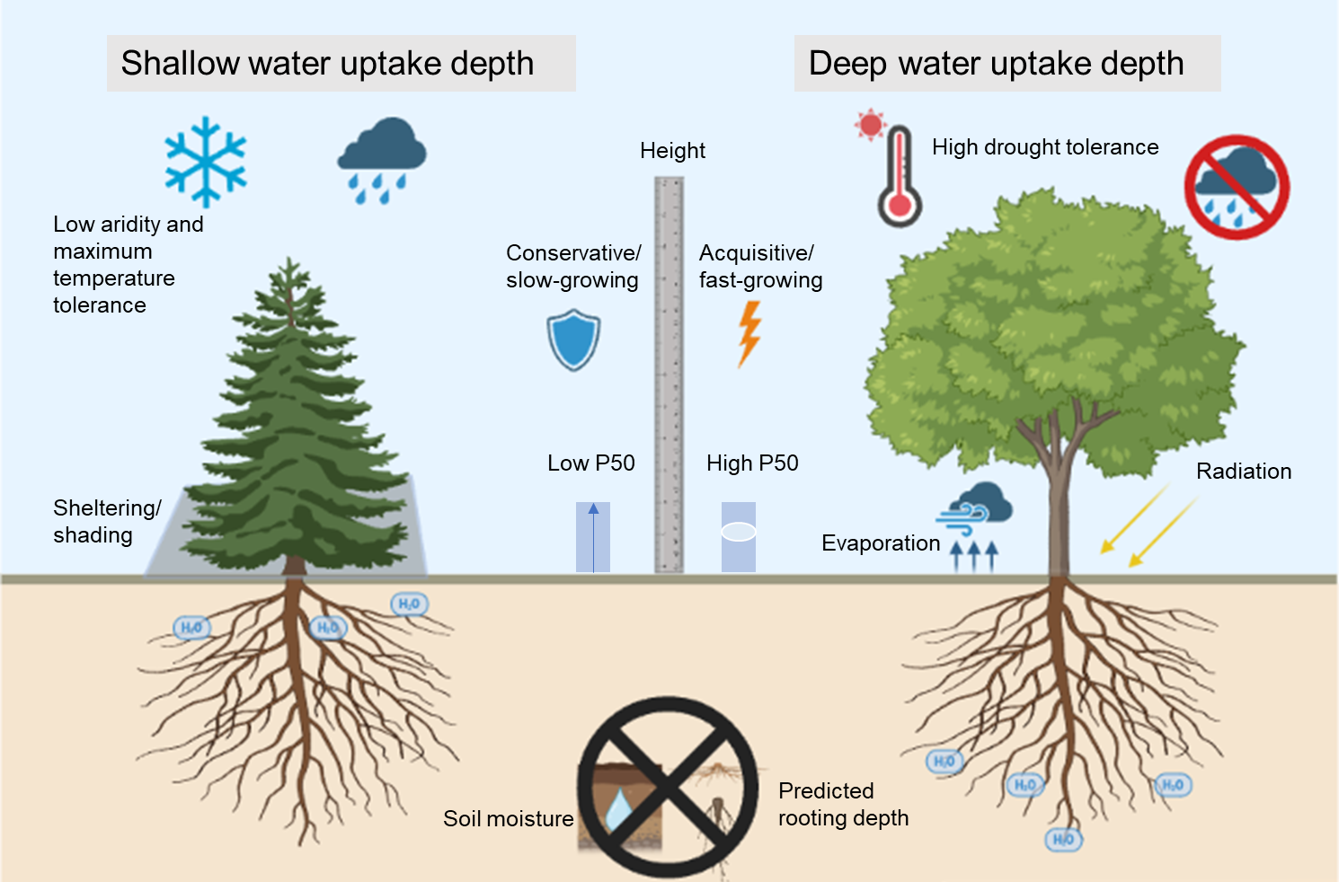
Keywords: Water uptake depth, stable isotopes, drought tolerance, ecohydrology, forest resilience, climate adaptation, rooting depth

Introduction
Water is a vital factor in determining both the productivity and distribution of plant species, making plant drought responses critical for their adaptation and success (Bradford & Hsiao, 1982; Volaire, 2018). Reduced water availability during droughts can have major impacts on the survival of plants and the functioning of ecosystems (Lambers & Oliveira, 2019). Across the world, there has been an increased occurrence of dry and hot conditions, as a result of climate change (IPCC, 2023), causing an increase in plant mortality in many biomes, including forests (Bastros et al., 2020; Hammond et al., 2022). Studies investigating interspecific differences in drought vulnerability of trees have focused on identifying physiological and hydraulic traits that predict hydraulic system vulnerability, but have yielded contrasting results (Hartmann et al. 2018; Hajek et al. 2022; Powers et al. 2020). A recent study by Kahmen et al. (2022) on nine temperate tree species showed that wood anatomy and stomatal control were insufficient to explain drought vulnerability, as these do not capture how quickly critical xylem tensions develop during drought (Cochard et al., 2021; Riffault et al., 2022). Instead, water uptake depth emerged as key predictor of water relations and hydraulic vulnerability. Here, we explore how the depth of water uptake in 40 tree species estimated with an oxygen isotope method relates to physiological, morphological and ecological traits reflecting drought strategies.
The depth of water uptake can be estimated using oxygen isotope ratio δ¹⁸O in aboveground tissue water (Ehleringer & Dawson, 1992). This method exploits the fact that a gradient in soil water δ¹⁸O develops due to variable incoming isotopic composition of precipitation and isotopic fractionation during evaporation. Lighter water (H₂¹⁶O) evaporates faster than heavier water (H₂¹⁸O), a process preferentially taking place in the top soil. When trees take up the heavier water primarily of the top soil their xylem water will be enriched with ¹⁸O compared to trees that extract water from deeper soil layers. Since trees take up water across a range of depths the δ¹⁸O signal of the tissue water represents a mix of water taken up in different layers. Extracting water from aboveground xylem tissues and analysing its oxygen isotope ratio δ¹⁸O thus enables inference on the depth of water uptake (Steger et al. 2026). The relative contribution of water uptake from different soil depths can be estimated using isotope mixing models. Although this is a well-established method, it has so far only been applied to a limited number of tree species per site (Bertrand et al., 2014; Brinkmann et al., 2019; Mas et al., 2024, Kahmen et al. 2022).
Root system architecture influences water uptake depth and drought avoidance, particularly through the vertical distribution of roots and soil–root hydraulic properties (Lobet et al., 2014; Freschet et al., 2021). Root distribution reflects both soil structure and species-specific coarse-root architecture (Schenk, 2005; Kutschera, 1960) as well as the localized fine-root proliferation where water and nutrients accumulate (Kazda & Schmid, 2009; Hodge, 2006). Shallow roots access nutrient-rich soils but are more vulnerable to drying, whereas deeper roots provide more stable water supplies at greater construction and maintenance costs (Kazda & Schmid, 2009). Trees must balance these trade-offs across soil depths. However, rooting depth alone does not reliably indicate water uptake depth (Kahmen et al., 2022); understanding species-specific strategies therefore requires independent measurements of water uptake depth.
Canopy structure can influence tree water uptake by modifying microclimate and soil water availability through effects on evaporation and rainfall interception (Norman & Campbell, 1989; Smith et al., 2008). The distribution and density of aboveground biomass determine the degree of sheltering within and beneath the canopy. Dense crowns reduce wind speed, incoming radiation, and vapour pressure deficit (Kuuluvainen & Pukkala, 1989; Renaud & Rebetez, 2009; von Arx et al., 2012), potentially reducing evaporative demand and slowing water loss from upper soil layers. These canopy-mediated microclimatic effects may therefore influence species-specific water uptake depth, a mechanism not yet considered in previous studies. In this study, terrestrial laser scanning (TLS) was used to quantify the sheltering potential of canopy structure against wind and radiation.
The slow–fast plant economics spectrum integrates coordinated resource-use traits across leaves, stems, and roots (Reich, 2014; Weigelt et al., 2021). Fast-growing species generally have higher water demands due to greater photosynthetic and growth rates (Reich, 2014; Schulze et al., 1994). Similarly, species maintaining growth during drought may require continued access to water. We quantified drought-growth resistance as mean growth during the consecutive drought years 2018–2020 relative to the pre-drought reference period (2016–2017) (Kretz et al., 2025). Both the slow–fast gradient and drought-growth resistance may therefore reflect species-specific water demand and acquisition strategies. We expect fast-growing and drought-resistant species to invest in deeper roots, although the benefits of this strategy likely depend on resource availability and species’ ecological niches.
Hydroclimate, particularly precipitation seasonality, strongly influences water uptake depth (Bachofen et al., 2024). Trees exposed to low air humidity at high temperatures also increase water uptake to compensate for operational and residual transpiration losses (Kuwagata et al., 2012; Wang et al., 2024). Because deeper soil water is more stable and less affected by evaporation, species from arid environments may be adapted to access deeper sources. Consistent with this, woody plants in arid grasslands and deserts use water sources approximately four times deeper than trees in humid temperate forests (Bachofen et al., 2024). Species in our study originate from regions with contrasting hydroclimates. Whether the species form drier climates express their ability to access deeper soil layers also under a more humid temperate climate remains unknown.
However, water availability also varies locally with geomorphology, creating hydrological gradients between habitats such as floodplains and uplands. Species sorting along these gradients is reflected in drought indicator values available for many temperate tree species (Niinemets & Valladares, 2006). These rankings characterize water availability at sites where species occur most frequently, drawing on studies of plant water relations and drought responses (Hsiao, 1973; Ludlow, 1989; Ellenberg, 1996; Chaves et al., 2002; Sack, 2004; Valladares et al., 2005), and may reflect physiological drought tolerance (Sack, 2004; Valladares et al., 2005). However, their relationship with water uptake depth remains unclear. We have a clear indication that temperate species associated with drier habitats have a less vulnerable xylem (Anderegg et al., 2013), but whether this is also reflected in deeper water uptake remains to be tested.
The ARBOfun research arboretum, located south of Leipzig, Germany, provides a unique setting to gain insight into the water uptake strategies of different species, as it consists of an extremely diverse set of tree species native to or commonly planted in Europe in a common garden design, ensuring uniform edaphic and climatic conditions across the site. The shared environment suggests that the trees in the experiment experience a similar soil water source, providing the opportunity to explore differences in the water uptake depth of 40 species estimated with the oxygen isotope method (Steger et al. 2026). By combining various predictors, including below- and aboveground morphological and anatomical traits, growth strategies, drought resistance behaviour, indicator values derived from habitat associations, drought tolerance indices derived from climatic data of their native distributions, and available soil moisture, we aim to shed light on the mechanisms controlling water uptake depth.
We developed the following hypotheses:
H1. Given the range of trait variation in the species studied, we expect to find strong differences in the water uptake depth estimate between species, derived from the δ¹⁸O from twig and soil water.
H2a. Species which are predicted to have deeper roots (according to their generic architecture type) take up a higher proportion of water from deeper soil layers.
H2b. Species with high xylem vulnerability (high P50 values) take up water from deeper water sources.
H2c. Because species on the fast side of the slow-fast gradient require more water to maintain their growth, they invest in deeper root structures to access the more reliable, deeper water sources.
H2d. Species that are able to maintain growth during drought periods (high growth resistance).
H2e. Trees that have a higher sheltering effect on the soil, due to a large and dense canopy close to the ground, take up water from shallower water sources.
H2f. Species with a realised niche of dry soil conditions (implying higher drought tolerance) have likely adapted to get water from deeper sources.
H2g. Trees experiencing higher humidity and lower temperatures in their native environments are expected to invest less in deep root development and rely on preferred shallow water sources.

Methods

Study material and site
This study was performed in the research arboretum, ARBOfun, located in Großpösna, south of Leipzig, Germany (51°16′N, 12°30′E), and is part of the German Centre for Integrative Biodiversity Research (iDiv) platform. The arboretum consists of 100 tree species; 69 planted in 2012 and 31 added in 2014. These species belong to 39 families, and are native to, or frequently planted in Europe. The experiment covers an area of 2.5 ha, with trees planted in a block design, consisting of 5 blocks, with each species being randomly planted in each block in a grid of 5.8 m x 5.8 m, resulting in a total of about 500 trees. For the purpose of this study, 120 trees were sampled; in 2025 these represent the Very Important Tree (VIT) selection. The aim of this selection was to identify 40 representative tree species (see Table A1, Supplementary Appendix 1) for sensor instrumentation, from a pool of 100 species (Table A2, Supplementary Appendix 1) to ensure that tree species span fundamental trait gradients reflecting the functional and phylogenetic diversity of the tree community (see Supplementary Appendix 2 for details on the selection process). The final selection consists of 27 angiosperms and 13 gymnosperms (Table A1 and Table A2, Supplementary Appendix 1). The mean annual precipitation at the arboretum from 1980-2020 was about 520 mm and the mean annual average temperature is 9.7°C. For the sampling year of this study, 2025, the mean precipitation was 510.6 mm with the wettest day (07 June) receiving 37.9 mm precipitation. The average temperature for 2025 was 10.59°C, with the hottest day reaching 37.1°C (02 June) (DWD Climate Data Center [CDC], Station Leipzig/Halle, ID 2932).
The soils in the wider study area have mostly developed from moraines or glacial deposits of the Saalian glaciation and periglacial deposits of the Weichselian glaciation (GÜK200, 2015). Three soil cores taken from the arboretum itself show that the stratigraphy contains sandy loess over ground moraines, with locally loamy to sandy facies. The cores furthermore showed that the area seems to be homogenous with respect to soil development, underlying substrates and their depths. This is supported by the mean soil water δ¹⁸O, which is similar across the same depths from the three locations (Supplementary Appendix 1, Figure A1). More details on the soil structure and the different horizons identified from the soil cores are explained in Supplementary Appendix 1.

Field and lab work
Three 10 cm-long twigs were sampled from each of the 120 tree individuals (VITs) (40 species with 3 replicates each), from random positions in canopy sectors facing different directions. Using a budding knife, the bark and cambium layer of the sampled twigs were removed up to the xylem layer. To reduce evaporation effects on isotope composition, the three xylem samples were directly placed into an airtight Exetainer vial (Labco Limited, UK) and sealed with parafilm and stored in a cooler-box with ice packs. The twig sampling was done over two days in Summer (05 and 11 June, 2025). On three separate days (11 April, 30 June and 04 August, 2025) during the growing season of 2025, soil cores were extracted (vibra-coring, with an Atlas Copco Cobra Pro hammer and 100 and 60 mm open corers) at three locations within the arboretum (Blocks A-C) (Figure A2, Supplementary Appendix 1). Ideally, soil cores would have been taken from below each individual tree, however, this was logistically not feasible due to the number of trees sampled. This limitation is addressed in more detail in the discussion. Twig and soil sampling were conducted under sunny, clear-sky conditions, with no sampling taking place immediately following rainfall events. The climate data of June 2025 shows that there was a total precipitation of 28.5 mm, a total of 293.2 hours of sun, an average cloud cover of 53%, a mean temperature (at 2m height) of 19.06°C and an average wind force of 2.9 on the Beaufort scale (DWD Climate Data Center [CDC], Station Leipzig/Halle, ID 2932). Twig sampling was purposefully conducted during the drier period of summer, when we expected differences in water uptake depth among species to be most pronounced. Under moist soil conditions, water is readily available across much of the soil profile, allowing species with different rooting distributions to access similar soil water sources. As soil moisture declines, however, shallow soil layers generally become depleted more rapidly, increasing the importance of deeper soil water sources. The ability to shift water uptake towards deeper soil layers therefore depends on species-specific rooting distributions and their capacity to adjust root activity in response to changing soil resource availability (Zanetti et al., 2015; Weemstra et al., 2017). Indeed, previous studies have demonstrated that tree species differ in their ability to shift water uptake towards deeper soil layers as topsoil water availability decreases (Brinkmann et al., 2019; Bachofen et al., 2024). Consequently, sampling during the drier summer period was expected to provide a better opportunity to identify differences in water uptake depth among species than sampling under conditions of high soil water availability.
From each core, soil was collected from seven depths (10, 20, 50, 100, 150, 200, and 250 cm, with 0 cm representing the soil surface), using sterilized spatulas, and inserted into a 12 mL Exetainer vial (Labco Limited, UK). The vials were sealed with Parafilm and stored in a cooler, to prevent evaporation effects. All the vials containing twig and soil samples were frozen after fieldwork. Water from xylem and soil samples was extracted using a custom-built cryogenic vacuum distillation system at the Swiss Federal Institute for Forest, Snow and Landscape Research (WSL, Birmensdorf), following Diao et al. (2023), after which the extracted water was transferred into 1.5 mL gas-tight glass vial and refrigerated until further analysis. A recent test by Steger et al. (2026) has confirmed the accuracy of using the cryogenic vacuum distillation (CVD) extraction for soil and xylem water for characterising the δ18O of plant source water (whilst δ2H values are associated with artefacts that require correction). During the extraction process, one twig sample was lost due to a leak in the vacuum, resulting in 119 samples.

Isotopes
δ¹⁸O measurements of water were done using a high-temperature reactor (TC/EA, Thermo Finnigan) with a tube-in-tube setup, coupled to a DeltaV isotope ratio mass spectrometer (IRMS, Thermo Fisher Scientific). A detailed description of the TC/EA setup and method used can be found in Gehre et al. (2004). All measurements are normalized to the VSMOW-SLAP scale by using in-house standard materials that are regularly measured against primary reference materials. The δ values are usually small numbers and are therefore multiplied by a factor of 1000 and reported in permille (symbol ‰). Every daily sequence contained quality control measurements (RWB-J1, target: δ¹⁸O(VSMOW-SLAP): target value ‰). The average δ¹⁸O(VSMOW-SLAP) value of RWB-J1 over all measurements shown here is 7.65±0.14 ‰.

Predictors

Index of rooting depth
We fitted a linear mixed-effects model of rooting depth against tree height, with species-specific random intercepts and slopes. Data came primarily from Kutschera & Lichtenegger’s (2002) online database, supplemented by the RSIP database (Tumber-Dávila et al., 2022) for seven species lacking data (Acer negundo, Picea sitchensis, Pinus ponderosa, Pseudotsuga menziesii, Cedrus deodara, Tsuga canadensis, Thuja occidentalis), yielding coverage of 35/40 species (87.5%). Because both databases report maximum rooting depth, original references were checked, retaining only direct measurements (e.g., excavated individuals) with corresponding tree heights and excluding literature-derived maxima and averages. All measurements were standardized to metres. Predicted rooting depth at a standardized height of 10 m was used to avoid uncertain extrapolation near the limits of observed height ranges.
Using the descriptions in Kutschera & Lichtenegger (2002), species were classified as deep-rooted, shallow-rooted, or variable (plastic/mixed strategy); classifications covered 29/40 species (73%). Predicted rooting depth correlated positively with atlas-based classifications (Spearman’s ρ = 0.53, p = 0.003; Figure A3, Supplementary Appendix 2), supporting its use as a species-specific root index in subsequent analyses of water uptake.

P₅₀ (Xylem embolism vulnerability)
P₅₀ (MPa) denotes the xylem pressure at which hydraulic conductivity is reduced by 50%; more negative values indicate greater resistance to embolism (Sperry & Tyree, 1988; Brodribb & Cochard, 2009). Values were obtained from Kretz et al. (2025), who gap-filled trait data from the Plant Trait Database (TRY) (Kattge et al., 2020), using hierarchical Bayesian probabilistic matrix factorization (BHPMF; Schrodt et al., 2015), a machine-learning method that predicts missing trait values based on taxonomic relationships.

Slow-fast axis position
A principal component analysis (PCA) was performed on seven functional traits expected to predict growth responses. Four traits—specific leaf area (SLA), leaf nitrogen content (LNC), carbon-to-nitrogen ratio (C:N), and stomatal density—were measured for individual ARBOfun trees and averaged by species. Wood density, stomatal conductance, and maximum photosynthetic assimilation rate (A_{max}) were obtained from the gap-filled TRY data (Kretz et al., 2025). Missing values (4.8%) were imputed using “missForest” (Stekhoven, 2025). The PCA was conducted on the complete dataset using “prcomp” from R’s “stats” package (R Core Team, 2026). PC1 primarily represented the slow–fast trait gradient (SLA, LNC, C:N, and A_{max}), with positive values indicating acquisitive traits (Supplementary Appendix 4, Figure A6). Species-specific PC1 scores were therefore used as an indicator of position along this gradient.

Growth Resistance to Drought
Kretz et al. (2025) calculated the growth response to drought of the trees in ARBOfun, for the consecutive drought years 2018, 2019 and 2020 compared to the pre-drought growth, which was calculated as the mean growth in the reference years 2016 and 2017. Growth was measured as the length of shoots built in the respective year. The growth response index is expressed as:
$${GR}_{dr.y}= \frac{b_{dr.y}}{b_{pre.dr.y}} (1)$$
Where $GR$ is the growth response, $b$ is the branch increment length, $dr.y$ is the drought year, and $pre.dr.y$ is the pre-drought reference period. The mean of the growth response over the drought years 2018, 2019, and 2020 was calculated for all tree species. Values greater than one (>1), therefore, show an increased growth during drought years relative to pre-drought years, whilst values smaller than one (<1) show decreased growth during drought year relative to pre-drought years. In this study, we refer to this index as the growth resistance to drought, as the growth of species during drought is an indicator of its ability to maintain growth during drought.

Sheltering index
Terrestrial Laser Scans (TLS) were done in July 2025 using a Leica RTC360 Laser Scanner (Leica Microsystems, Wetzlar, Germany) to obtain 3D point clouds for all trees in ARBOfun. These were used to construct an index approximating the ground shading potential of each tree, by segmenting each tree and manually freeing it from the ground points. Ground was normalised and duplicate points were removed, using the “lidR” package in R (Roussel et al., 2021). The final index (SI) was calculated as:
$$SI= \frac{\sqrt{A}∙ \overline{PAI}}{ \overline{d}} (2)$$
Where $A$ is the projection area of the tree crown, $\overline{d}$ is the mean distance between the ground and the beginning of the tree crown and $\overline{PAI}$ is the Plant Area Index.
The AMAPvox software (Vincent et al., 2017) was used to calculate $A$, $\overline{d}$ and $\overline{PAI}$ from voxelised point clouds, with a voxel size of 0.2 m. Plant Area Densities (PAD) (estimated using the Free Path Length Estimator method) (Verley, 2026), provided for each voxel in AMAPvox, were used to calculate PAI, using the free path length estimator method following Pimont et al., (2018). The PAD of all the voxels in one vertical column (along the z-axis) of the tree crown were summed to get the PAI of that column. The final $\overline{PAI}$ for each VIT, is the mean of PAI of all vertical columns. $A$ is calculated as the sum of the base area of all vertical columns that have at least one point-filled voxel. $\overline{d}$ is calculated as the mean of all distances between ground (z = 0) and the first vegetation-filled voxel in each vertical column.

Drought tolerance
Drought tolerance indices for the 40 VIT species were obtained from Niinemets & Valladares (2006), who synthesized species-specific rankings from literature and databases. For North American species, scores from multiple studies and the USDA Plants database (1 = very intolerant; 5 = very tolerant) were strongly correlated and averaged. For European species, drought tolerance was assessed using sources including Ellenberg’s (1991) soil-moisture indicator values, reflecting species occurrence along moisture gradients under interspecific competition. The resulting standardized index (1–5) integrates site-based indicators and physiological tolerance, defined by the minimum soil water potential tolerated long-term with less than 50% foliage damage. Higher scores indicate greater drought tolerance.

Temperature and Aridity tolerance indices
Species-level climatic niches were characterized using quantiles of occurrence records from the Global Biodiversity Information Facility (GBIF; GBIF.org, 2025). Records were aggregated to ~5-km resolution using a zoom-level-5 hexagonal grid (32 tiles, each containing 51 cells along its length); overlapping edge hexagons were averaged to reduce boundary artefacts. WGSRPD Level 3 botanical countries (Brummitt, 2001) and native-range data from rWCVP (Brown et al., 2023), which interfaces with Plants of the World Online (POWO, 2025), distinguished native from introduced occurrences. The resulting 468.4 million records supported species distribution mapping, identification of regions of origin and associated climatic zones, and derivation of heat- and drought-tolerance indicators.
Occurrence records were linked to WorldClim 2.1 monthly minimum and maximum temperatures for 1970–2000 (~1-km resolution; Fick & Hijmans, 2017), from which the highest monthly maximum temperature per location was extracted. Drought was characterized using Version 3 of the Global Aridity Index and Potential Evapotranspiration Database (Zomer et al., 2022). Species-specific 90th percentiles of maximum temperature (q90) and 10th percentiles of the aridity index (q10) represented upper heat tolerance and drought resistance, respectively.

Soil moisture
Soil moisture was measured in the upper soil layer (0–15 cm) using frequency domain sensors (FDR) of the SMT100 type (Ecomatik GmbH, Dachau, Germany). Each of the 120 sensors was installed 50 cm from the base of the trunk on the north side of each VIT tree. The sensors were set to take readings daily, at 15-minute intervals. The soil moisture for 2 days prior to, and the day of, each twig sampling date was extracted; 3-5 June and 9-11 June. This was done to avoid including soil moisture data from the precipitation events (which occurred on the 7th and 8th of June), as this significantly influences the short-term topsoil moisture. The mean soil moisture for these six days was calculated for each sensor/VIT.

Data analyses
All analyses were conducted in R (version RStudio 2026.04.0+526).

Species differences and source water uptake depth
The δ¹⁸O results of the twig water (δ¹⁸O_{twig}) were tested for outliers. The effect of species on δ¹⁸O_{twig}, was evaluated using a linear mixed-effect model. The significance of species on source water (δ¹⁸O_{twig}) was tested using analysis of variance (ANOVA) (“aov” function in “stats” package (R core team, 2026)).
A two-end member mixing model, which assumes that δ¹⁸O_{twig} reflects a mixture of two sources (von Freyberg et al., 2020), was used based on the clear difference between the top 20 cm and the lower depths seen in preliminary results (Figure A4, Supplementary Appendix 3). This approach provides a robust index of water uptake depth.
The conceptual two-end member mixing model can be described mathematically with the function:
δ¹⁸O_{twig} = f_{shallow} *δ¹⁸O_{shallow} + (1-f_{shallow})* δ¹⁸O_{deep} (3)
where,
f_{shallow} = fraction of water from shallow soil, and,
1- f_{shallow} = fraction from deep soil (f_{deep}).
Shallow water was defined as soil water from 0–20 cm depth and deep water as water below 20 cm. Because shallow-soil δ¹⁸O varied significantly across sampling dates (Figure A5, Supplementary Appendix 3), only the two summer sampling dates (30 June and 4 August 2025), closest to twig sampling, were included. δ¹⁸O_{shallow} was calculated as the mean soil δ¹⁸O across both dates and all three locations at 10 and 20 cm depth, while δ¹⁸O_{deep} was averaged across the same dates and locations at 50, 100, 150, 200, and 250 cm. A two-end-member mixing model was applied to each tree, with source-water fractions constrained to [0,1], to estimate the relative contributions of shallow and deep soil water.

Predictors of species water uptake patterns
A Spearman correlation matrix was computed for all initial variables except f_{shallow} using imputed data and the “corr.test” function in R’s “psych” package (Revelle, 2010). Spearman’s rank correlation was used to assess pairwise associations because some relationships were nonlinear and unsuitable for Pearson correlation.

Effects of predictors on water uptake depth
A random forest regression model was used to identify the important mechanisms driving water uptake depth. The model had the following structure:
f_{shallow} ~ predicted root depth + sheltering index + slow-fast position axis + growth resistance to drought + aridity tolerance index + maximum temperature tolerance index + soil moisture + drought tolerance + height + P50
Random forest models (RFMs) were selected because preliminary analyses revealed nonlinear relationships that could not be adequately captured through transformations or quadratic terms (Breiman, 2001). Missing predictor values (6.2%) were imputed using “missForest” (Stekhoven, 2025) with 2,500 trees and up to 100 iterations. The complete dataset was used in subsequent analyses. A regression RFM was fitted using “ranger” (Wright & Ziegler, 2017), and recursive feature elimination (RFE) sequentially removed the least important predictor, evaluating each model using out-of-bag (OOB) R² and RMSE. The model with the highest R² retained eight predictors, which were used to fit the final model.
Predictor importance and significance were assessed using “rfPermute” (Archer, 2025), with 1,000 response permutations. Importance was quantified using the percentage increase in mean squared error (%IncMSE), with higher values indicating greater predictive importance; associated p-values assessed significance. Partial dependence plots (PDPs) based on the final model illustrated marginal predictor effects on f_{shallow} across observed predictor ranges. Potential interactions were investigated using “iml” (Molnar et al., 2018), quantifying interaction strength and generating two-dimensional partial dependence surfaces. Four pairs were examined: drought and aridity tolerance, sheltering index and drought tolerance, drought growth resistance and sheltering index, and tree height and drought tolerance. These pairs were selected based on interaction strengths and theoretical considerations (Supplementary Appendix 4, Figure A6).

Results

Individual and tree species differences
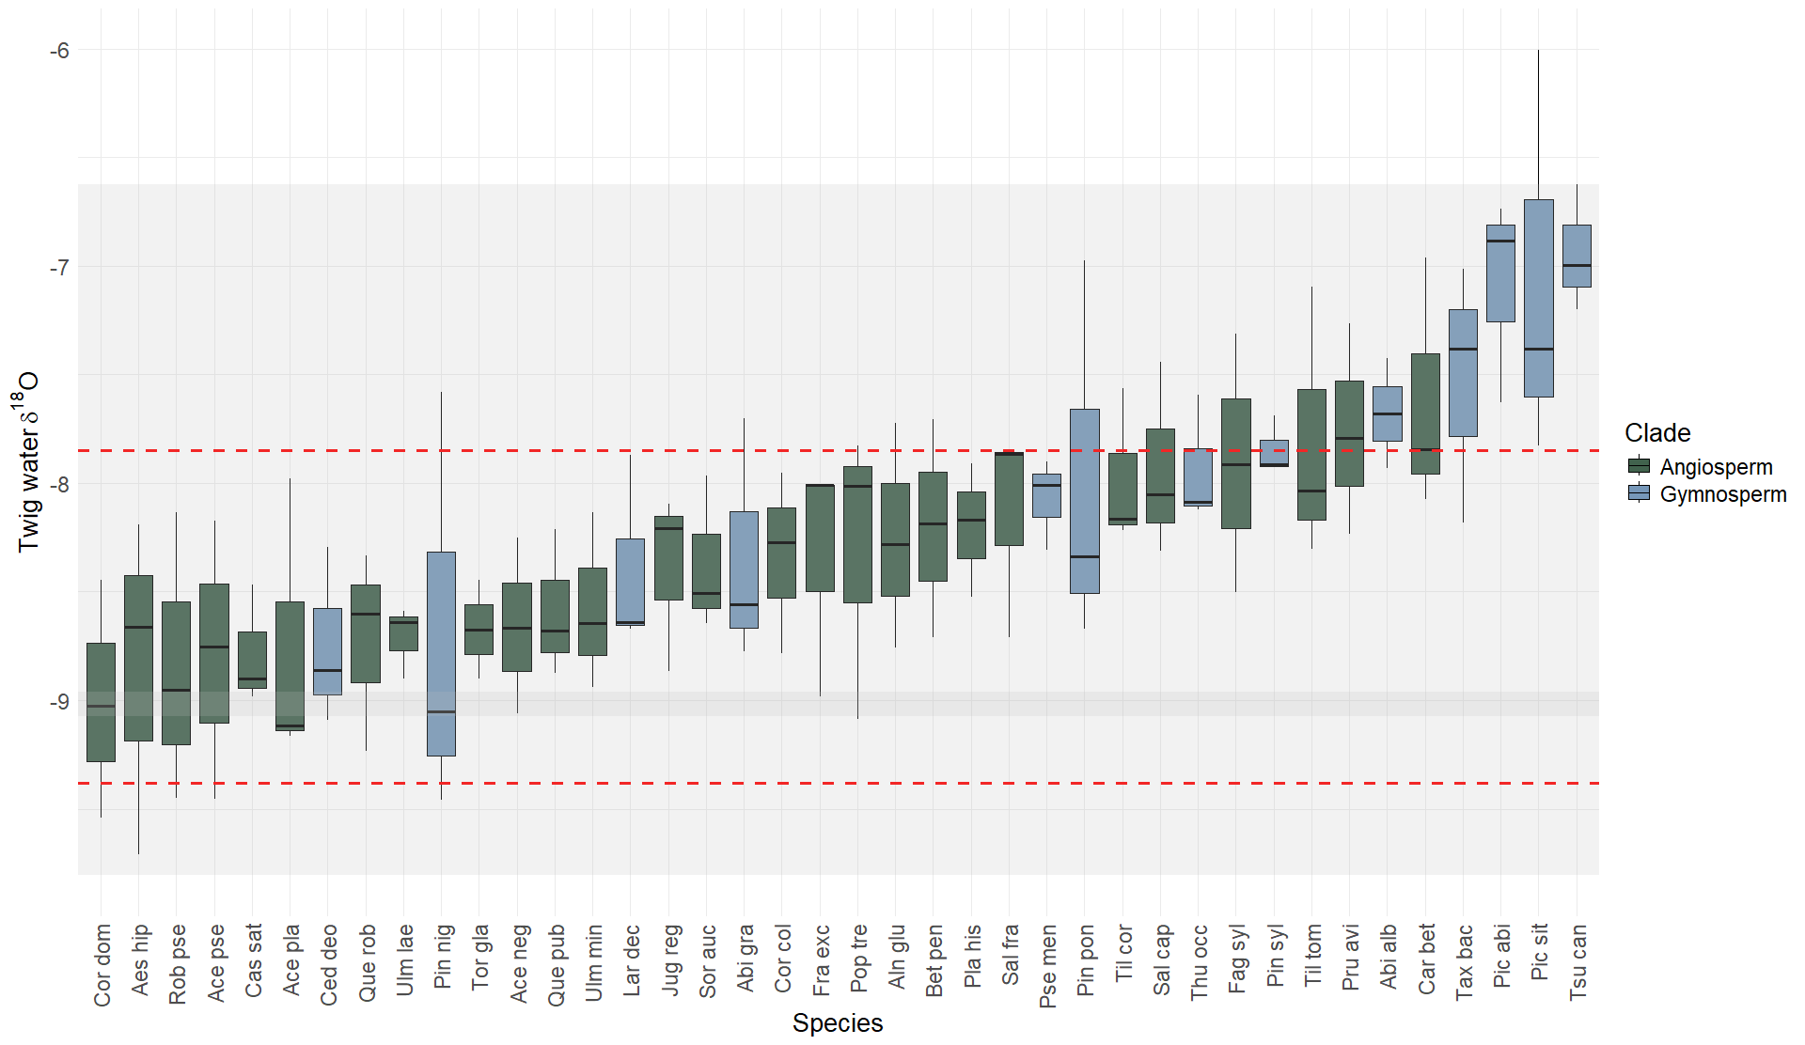
The boxplots of the twig water δ¹⁸O (δ¹⁸O_{twig}) of species (Figure 1) show that there is variation in source water between individuals, even within the same species. An ANOVA showed that there are significant differences in the mean δ¹⁸O_{twig} between species (F = 2.8, p < 0.001).
Figure 1: Boxplots of the δ¹⁸O of the twig water (xylem) across species (see Supplementary Appendix 1 for full species names). Boxplots are ranked from lowest to highest species mean δ¹⁸O. Species are coloured according to their clade; angiosperms in green, and gymnosperms in blue. The dashed red lines indicate the mean soil water δ¹⁸O of shallow (-7.8‰) and deep (-9.4‰) layers, where shallow layers include depths ≤20cm (10 and 20cm) and deep layers are depths >20cm (50, 100, 150, 200, 250cm). The grey shaded area indicates the standard deviations of the mean shallow and deep soil water δ¹⁸O.
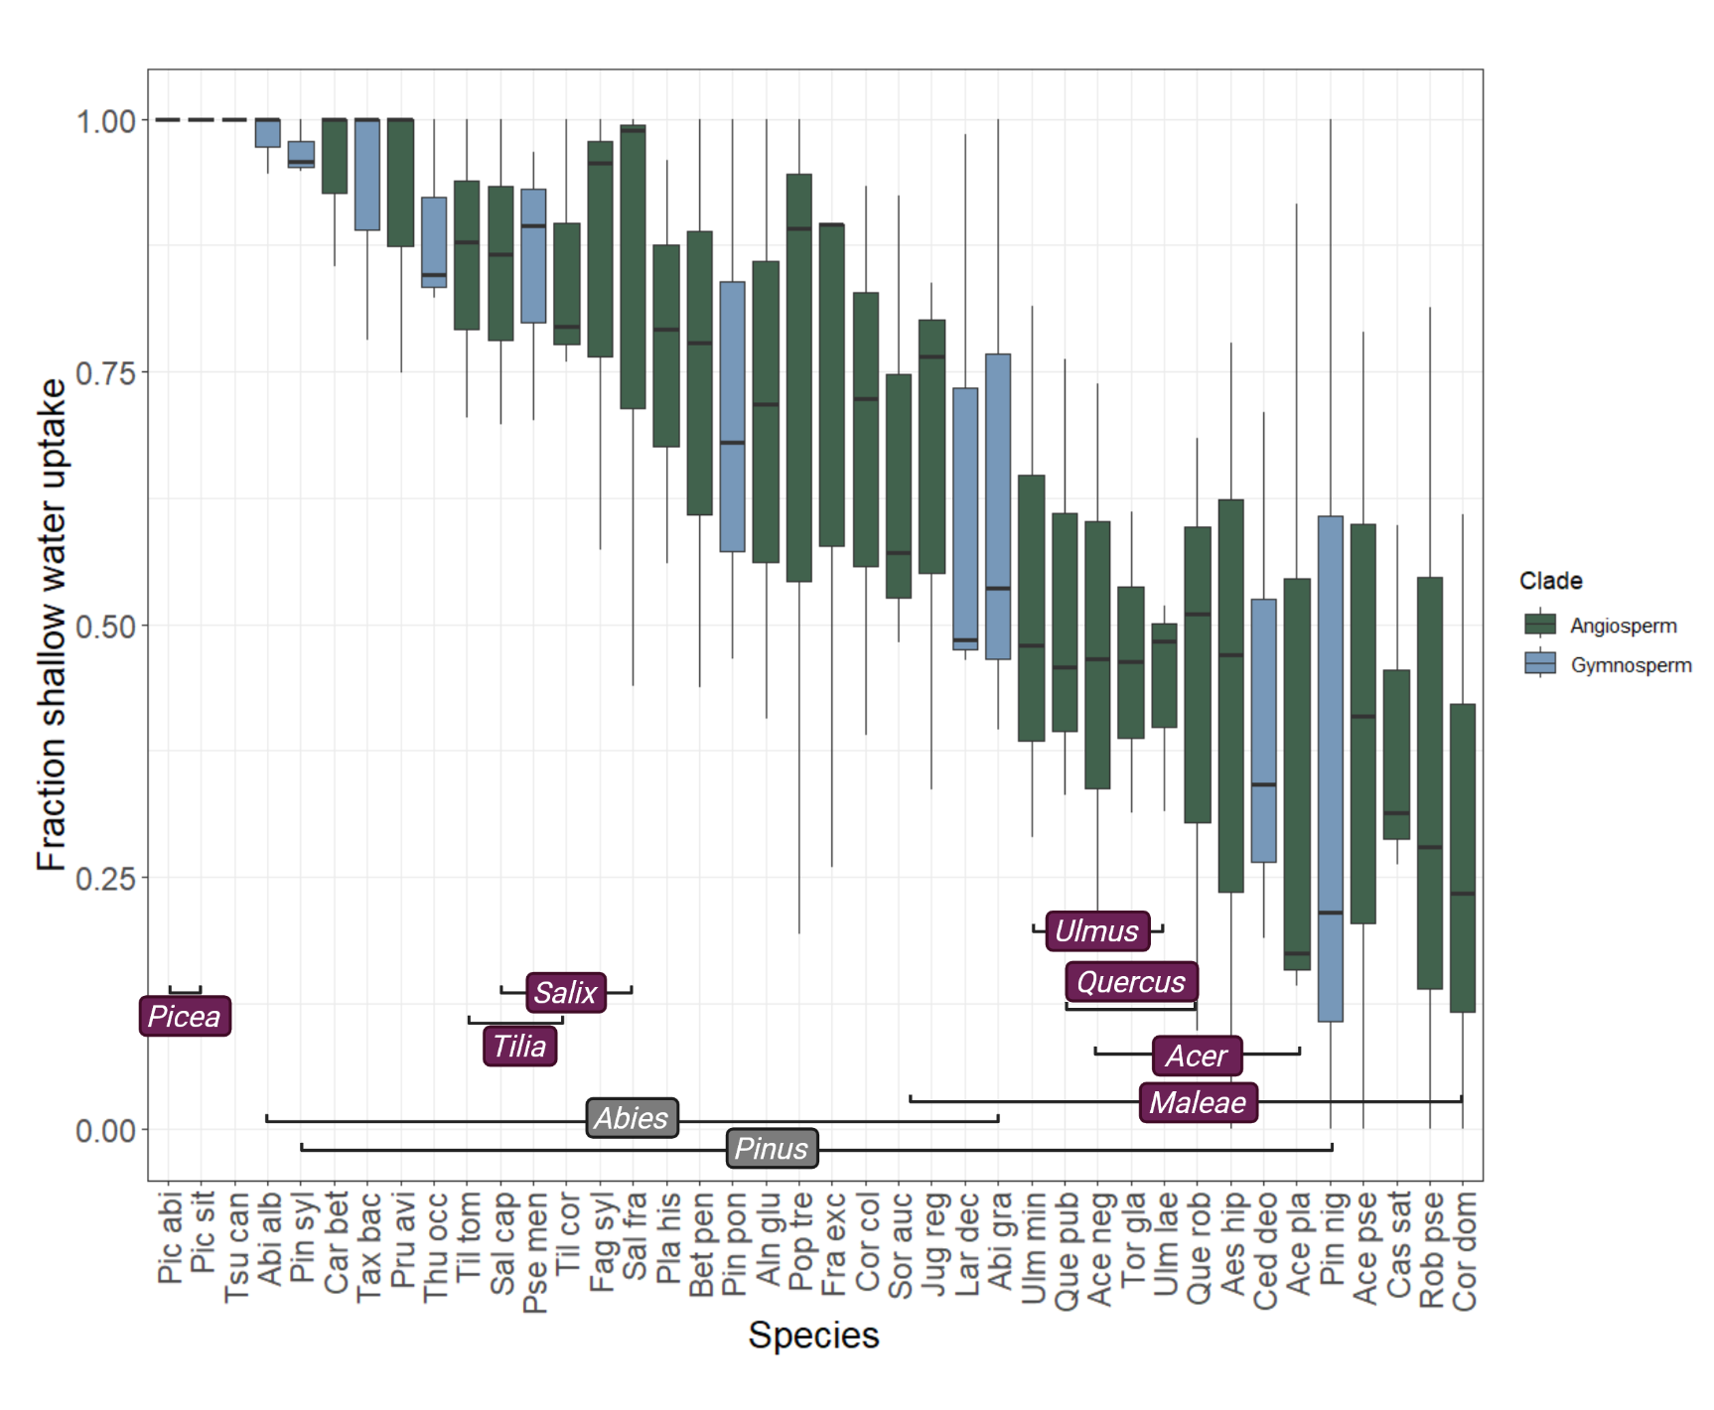
Applying the two-end member mixing model (Eq. 3), the plot of the fraction of water taken up from shallow sources (f_{shallow}) for the individuals within the different species (Figure 2), confirms that species differ in their water uptake sources, with some species getting all their water from only shallow sources (f_{shallow} = 1), whilst others get over fifty percent (50%) of their water from deeper sources. Among the top ten values for f_{shallow} are seven conifers. Interestingly, species within the same genus mostly show similar water uptake patterns (see similar f_{shallow} of genera Acer, Salix, Quercus, Picea, Maleae (all former names were Sorbus), Ulmus, Tilia). Only two genera exhibited strong inter-generic differences (Abies, Pinus). From Figure 2, it is also clear that there is large intraspecific variation in f_{shallow}.
Figure 2: Plot showing the fraction of water taken up from the shallow layers (f_{shallow}) of soil ($≤$20cm), by different tree individuals within the same species. Boxplots are ranked from highest to lowest species mean f_{shallow}. Species are coloured according to their clade; angiosperms in green, and gymnosperms in blue. Genera with species showing similar water uptake patterns are shown in purple and genera with diverse water uptake patterns are shown in grey.

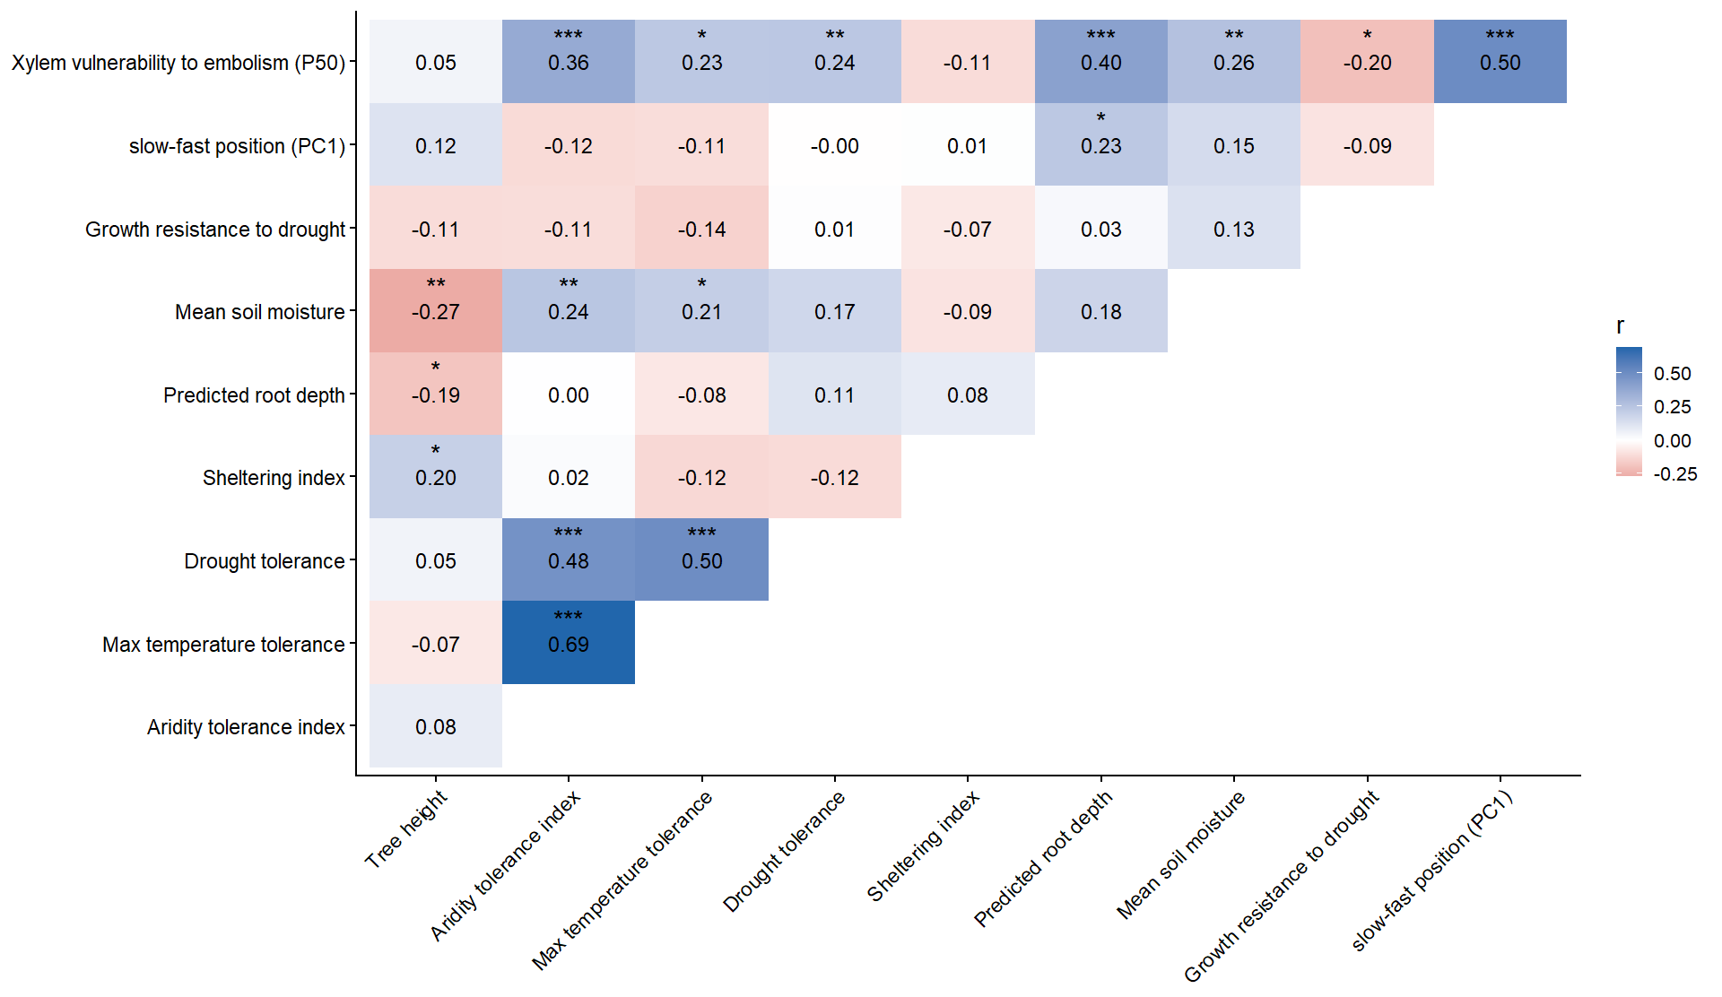
Predictors of species water uptake patterns
Figure 3: Correlation matrix of global model predictor variables. Colours indicate the strength and direction of pairwise Spearman correlation coefficients, with blue representing positive correlations and red representing negative correlations. Correlation coefficient values are shown within each cell. Significance levels were indicated using asterisk notation based on p-values, where correlations with p < 0.05 were marked with *, p < 0.01 with **, and p < 0.001 with ***. Non-significant correlations (p ≥0.05) were left unmarked.
Tree height was negatively correlated with predicted rooting depth (r = −0.19, p = 0.04), whereas slow–fast position was positively correlated (r = 0.23, p = 0.001; Figure 3), indicating deeper predicted roots in more acquisitive species. Topsoil moisture was negatively correlated with tree height (r = −0.27, p < 0.01) but positively correlated with aridity tolerance (r = 0.24, p < 0.01) and maximum temperature tolerance (r = 0.21, p = 0.02). The two climatic tolerance indices were strongly correlated (r = 0.69, p < 0.001); drought tolerance was also positively correlated with aridity tolerance (r = 0.48, p < 0.001) and maximum temperature tolerance (r = 0.50, p < 0.001), indicating an association between adaptation to hot, dry climates and tolerance of dry soil conditions. P₅₀ was positively correlated with aridity tolerance (r = 0.36, p < 0.001), maximum temperature tolerance (r = 0.23, p = 0.01), drought tolerance (r = 0.24, p < 0.01), predicted rooting depth (r = 0.41, p < 0.001), mean soil moisture (r = 0.26, p < 0.01), and slow–fast position (r = 0.50, p < 0.001). It was negatively correlated with growth resistance to drought (r = −0.20, p < 0.01). Thus, higher P₅₀ values were associated with deeper predicted rooting, more acquisitive traits, greater climatic and drought tolerance, wetter topsoil, and lower growth resistance to drought.

Effects of predictors on water uptake depth
The final eight-predictor random forest model had limited explanatory power (OOB R² = 0.20; MSE = 0.075; Table 1). Aridity tolerance, drought tolerance, and sheltering index were the strongest predictors of f_{shallow}. Xylem embolism vulnerability (P₅₀), maximum temperature tolerance, slow–fast position, and growth resistance to drought also showed significant variable importance (p < 0.05), while height was retained but had borderline significance (p = 0.058). Contrary to expectations, predicted rooting depth and soil moisture had little predictive importance. Greater deep-water uptake (lower f_{shallow}) was generally associated with origins in hotter, drier climates, greater drought tolerance, less sheltered rooting zones, taller stature, acquisitive traits, and higher local growth resistance to drought. Overall, water-uptake strategies were associated with species’ climatic adaptations, local habitat conditions and physiological and growth-related traits.
Table 1: Variable importance from the random forest model predicting f_{shallow} (fraction of shallow water uptake), based on permutation importance (%IncMSE) and associated significance values derived from 1000 permutations. Higher %IncMSE values indicate greater importance of a predictor in reducing model accuracy when permuted.
Predictor | %IncMSE | p-value
Aridity tolerance index | 29.46 | 0.001
Drought tolerance | 24.81 | 0.007
Sheltering index | 23.18 | 0.007
Xylem embolism vulnerability (P50) | 20.42 | 0.012
Maximum temperature tolerance | 19.60 | 0.013
Slow-fast position (PC1) | 15.80 | 0.020
Growth resistance to drought | 13.60 | 0.045
Height | 12.65 | 0.058
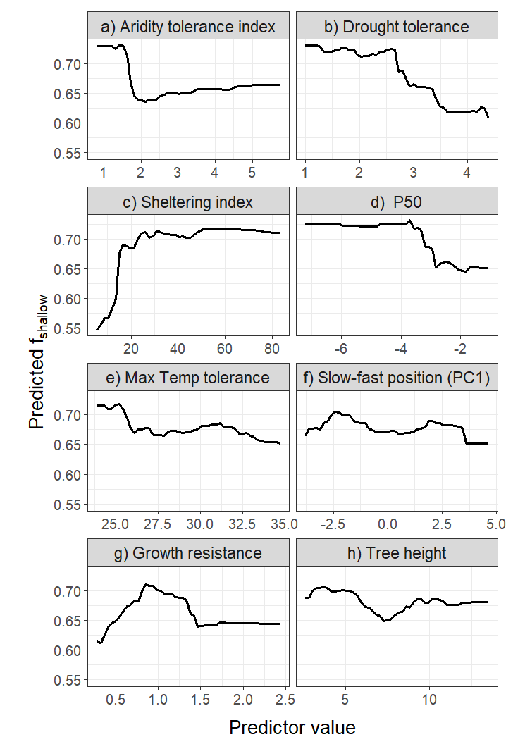
Figure 4: Partial dependence plots (PDPs) showing the marginal effect of each predictor on the model’s predicted response (f_{shallow}), while averaging over all other variables in the random forest. Each panel represents a single predictor, with the x-axis showing the observed range of that variable and the y-axis showing the corresponding change in predicted f_{shallow}. For a) the unit was multiplied by ten thousand for visualisation. These plots illustrate potential non-linear relationships and the direction and strength of each predictor’s influence on model output.
Partial dependence plots (PDPs) showed approximately linear negative relationships between predicted f_{shallow} and drought tolerance (Figure 4b), maximum temperature tolerance (Figure 4e), slow–fast position [PC1] (Figure 4f), and tree height (Figure 4h). Sheltering index (Figure 4c) showed a steep increase in predicted f_{shallow} at low values, followed by a plateau. Aridity tolerance (Figure 4a) and xylem vulnerability to embolism (P₅₀; Figure 4d), showed stepwise patterns: predicted f_{shallow} remained high at low aridity index and P50 values and then dropped sharply. The effect of growth resistance to drought (Figure 4g) was less clear, consistent with its low permutation importance (Table 1) but relatively high overall interaction strength (Supplementary Appendix 4, Figure A7), suggesting its effects may depend on interactions with other predictors.
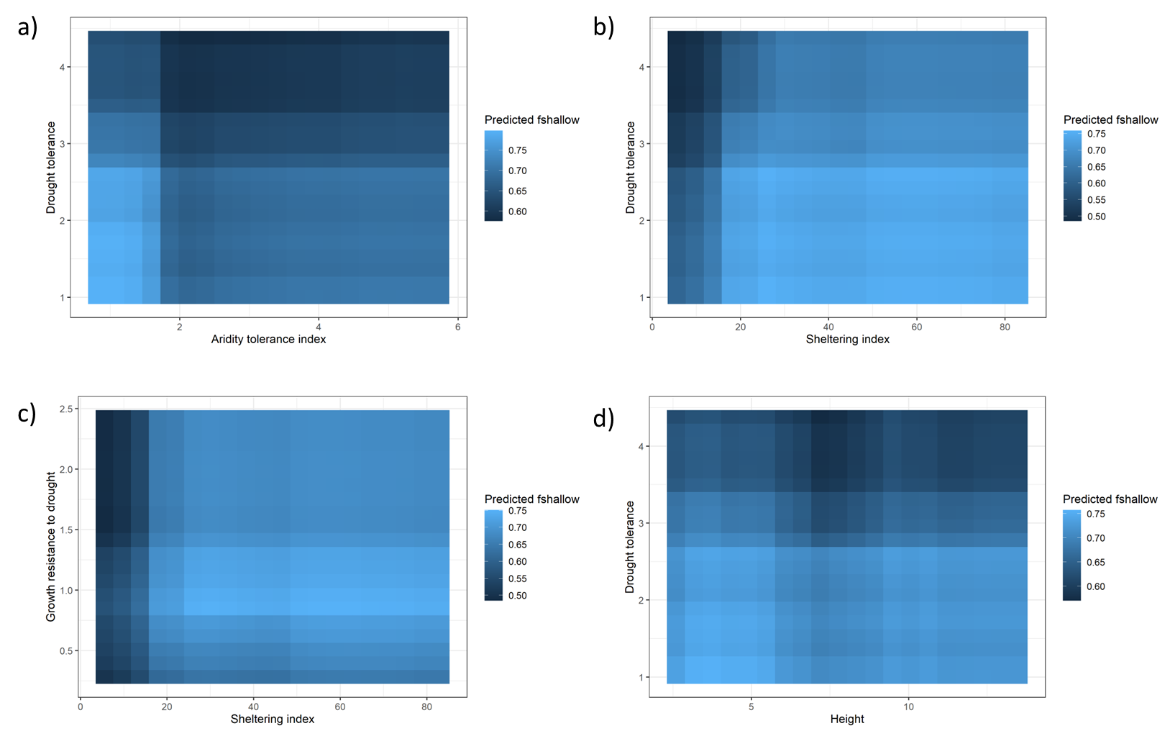
Figure 5: 2D Partial Dependence Plots (PDPs) visualizing the marginal effect two predictors have on the predicted outcome of the model (f_{shallow}). This plot looks specifically at possible interactions between a) drought tolerance and aridity tolerance index, b) drought tolerance and sheltering index, c) growth resistance to drought and sheltering index and d) drought tolerance and height.

Interactions between predictors
The effect of the aridity tolerance index on f_{shallow} changes with changes in the drought tolerance and vice versa (Figure 5a). Species with a low aridity and low drought tolerance index get most of their water from shallow sources, whilst species with a high aridity tolerance and high drought tolerance take up water from deeper sources (lower f_{shallow}) than species with a lower drought tolerance. From the correlation matrix (Figure 3), we see that drought tolerance and aridity tolerance index are positively, significantly correlated (r= 0.48, p<0.01). Figure 5(b and c) confirm that the predicted shallow water use increased strongly with increasing sheltering, particularly at low sheltering values, before reaching an apparent asymptote. Drought tolerance and growth resistance to drought had a comparatively weak effect, with a possible peak in shallow water use at low drought tolerance and intermediate resistance values. The relatively uniform colour gradient across drought tolerance (Figure 5b) and growth resistance to drought (Figure 5c) suggests limited interaction with sheltering index. From the interaction plot between drought tolerance and height (Figure 5d) we see that the dominant pattern occurs in drought tolerance; more drought-tolerant trees rely less on shallow water sources. The predicted f_{shallow} changes slightly with changes in height, suggesting that height alone is not a strong driver of water uptake depth. But the effect of height does change slightly with changes in drought tolerance; at low drought tolerance, the predictions of the proportion of shallow water uptake (f_{shallow}) remain relatively high across all heights, whilst at high drought tolerance, height seems to matter more and results in taller individuals having slightly lower predicted f_{shallow} values (getting water from deeper sources).

Discussion

Interspecific variation in water uptake depth
Tree species differ significantly in their water uptake depth as derived from a stable isotope mixing model. In the top ten species with the highest fraction of shallow water use (f_{shallow}), seven are conifers and species within the same genus mostly show similar water uptake pattern. Species differences can be explained by a combination of predictors related to climate niche, drought resistance and morphology, albeit with low predictive power. The most important predictors of the fraction of shallow water uptake are the aridity tolerance, drought tolerance, sheltering index, vulnerability to xylem embolism and maximum temperature tolerance. Tree species relying on deeper water sources tend to originate from or have distribution centres in drier and hotter climate regions, have high drought tolerance values indicating an association with edaphically dry conditions, have a sunlit rooting zone little sheltered by an elevated and transparent canopy (low sheltering index) and have a higher vulnerability to xylem embolism. A weaker, but significant relationship includes the tendency of fast-growing trees to use deeper water. The same holds for taller trees (almost significant relationship). Importantly, available information on soil moisture and the potential rooting depth and root architecture was not related to the fraction of deep water uptake.

Predictors of water uptake depth

Index of rooting depth
Surprisingly, predicted rooting depth was not an important predictor of f_{shallow}, contradicting H2a. While morphologically shallow-rooted species may be constrained to shallow water sources, deeper roots appear to increase flexibility in water acquisition rather than determine uptake depth (Choat et al., 2018; Nardini et al., 2021). Consistent with vertical root distribution trade-offs, Figure 2 shows a continuum of water-use strategies, with most species accessing both sources. Whilst deep roots provide access to stable water reserves during drought, they also incur greater construction and maintenance costs and may limit access to nutrient-rich topsoil (Kazda & Schmid, 2009). Shallow soil typically contains more organic matter, supporting nutrient mineralisation and water retention (Schenk, 2005). When water is sufficiently available, these benefits may outweigh those of deep rooting. In addition, predicted rooting depth may be a weak predictor of f_{shallow}, as root systems contribute not only to water acquisition but also to mechanical anchorage, with their effectiveness depending on root architecture and soil properties (Dupey et al., 2005). This, together with the fact that the sampling was not done in extreme drought conditions, could explain why some species, for example Pinus sylvestris, which are known for having deep tap roots, still take up water from shallow soil layers in this study.
Fast-growing species generally had deeper predicted roots (Figure 3), suggesting that rooting depth may indirectly reflect water demand associated with growth, although a higher realised rooting depth in our arboretum may also result from a larger body size after 12–14 years. These findings support previous evidence that rooting depth alone is a poor proxy for water uptake depth (Nippert & Holdo, 2015). Limited species coverage and difficulties obtaining comparable, species-level rooting-depth estimates may also have weakened the predictive power (Kutschera & Lichtenegger, 2002; Tumber-Dávila et al., 2022). Improved methods and root trait datasets are therefore needed to clarify the relationship between rooting architecture and water uptake.

Xylem embolism vulnerability (P₅₀)
Higher P₅₀ values (greater embolism vulnerability) were associated with lower f_{shallow}, indicating greater deep-water uptake and supporting H2b. These results are consistent with Kahmen et al. (2022). This relationship reflects the contribution of P₅₀ when accounting for the other predictors included in the model, suggesting that hydraulic adaptations may provide an additional dimension of drought resistance beyond the primary influence of climatic adaptations. Drought-induced hydraulic stress occurs when atmospheric demand exceeds water supply, primarily through loss of root–soil contact as soils dry (Johnson et al., 2018; Körner, 2019; Passot et al., 2019; Carminati & Javaux, 2020; Rodriguez-Dominguez & Brodribb, 2020) or xylem embolism restricting water transport (Tyree & Sperry, 1989; Cochard, 1992). The negative correlation between P₅₀ and growth resistance to drought (Figure 3) suggests that greater embolism vulnerability is associated with lower resistance to drought-induced hydraulic stress. This is supported by the positive correlation between P₅₀ and drought adaptation, aridity, maximum-temperature, and drought tolerance indices (Figure 3) - all suggesting that trees exhibiting adaptations to water limitation tend to rely more strongly on deeper soil water sources.
P₅₀ was also positively correlated with slow–fast position and predicted rooting depth, potentially reflecting a trade-off between hydraulic efficiency and safety (Hacke et al., 2006; Markesteijn et al., 2011; De Guzman et al., 2016; Li et al., 2023). Xylem structure influences this trade-off between efficient water transport with low carbon investment and minimizing drought-induced cavitation (Grossiord et al., 2020). Deep-rooted species with access to the more stable deep water sources and acquisitive species with high growth-related water demands may prioritize hydraulic efficiency over safety, increasing their vulnerability to embolism.

Slow-fast position and Height
Although tree height and the slow–fast gradient were not correlated (Figure 3), taller trees and more acquisitive species preferentially relied on deeper water sources, supporting H2c. As trees were of the same age, height differences likely reflect species-specific growth. The positive relationship between acquisitive traits and predicted rooting depth suggests greater belowground investment, whereas taller stature may reflect greater aboveground biomass and water demand. These contrasting relationships, potentially compounded by differences between gymnosperms and angiosperms, may explain the lack of correlation between height and the slow–fast gradient.
Previous studies report mixed relationships between water uptake depth and hydraulic sensitivity, although acquisitive, often anisohydric, deep-rooted species may switch more readily between water sources than conservative, often isohydric, species (Grossiord et al., 2017; Bachofen et al., 2024). At the Swiss Canopy Crane, hydro-stability was related to uptake depth, although acquisitive pioneer species were absent (Kahmen et al., 2022). Muñoz-Gálvez et al. (2025) similarly found that taller woody species used more deep water and had more conservative leaf traits, whereas smaller species relied more on shallow water and exhibited water-spending strategies. Acquisitive species may also have more light-demanding, transparent crowns that provide less microclimatic buffering (Pacala et al., 1996).
Height was less important than the slow–fast gradient in predicting water uptake depth, potentially because its effect depended on drought tolerance (Figure 5d). Taller trees tended to rely more on deeper water uptake at higher drought tolerance, suggesting that tree size interacts with physiological adaptations to shape water acquisition. Tree size and stand structure should therefore be considered when interpreting species-level water-use strategies, particularly under increasing drought stress.

Growth Resistance to Drought
The ability of species to maintain growth during drought reflects an important component of drought adaptation and may influence the strategies used to access water. Species with greater growth resistance to drought are expected to maintain carbon assimilation during periods of water limitation through physiological adaptations that preserve hydraulic function and carbon balance (Chaves et al., 2003; McDowell et al., 2008). However, the relationship between drought growth resistance and water uptake depth is unlikely to be linear (as seen in Figure 4g) because the benefits of accessing deep water depend strongly on the environmental context and the relative availability of shallow versus deep water pools (Ehleringer & Dawson, 1992). Therefore, H2d cannot be accepted. The interaction with the sheltering index (Figure 5c) indicates that species’ water-use strategies vary with the degree of microclimatic buffering, with drought-resistant species showing a stronger response than species less able to maintain growth under drought. Under sheltered conditions, trees may preferentially take up water from the upper soil layers, whereas in more exposed environments, greater atmospheric demand may increase reliance on deeper, more stable water sources (Grossiord et al., 2017; Davis et al., 2019). This highlights that drought adaptation may involve the capacity to adjust water acquisition strategies according to environmental constraints.

Sheltering index
Trees with higher sheltering indices relied more on shallow water, whereas those with lower indices used deeper water sources, supporting H2e. This relationship plateaued at higher sheltering values, with only trees with very low indices consistently relying on deeper water (Figure 4c). Canopy sheltering can reduce evaporative stress, wind exposure, incoming radiation, and vapour pressure deficit (Hasselquist et al., 2018; Renaud & Rebetez, 2009; Kuuluvainen & Pukkala, 1989; von Arx et al., 2012), buffering the microclimate and potentially favouring shallow water uptake. In less sheltered conditions, greater atmospheric demand may increase reliance on deeper, more stable water sources.
Contrary to expectations, sheltering was not significantly related to measured soil moisture. Although canopy buffering may reduce soil evaporation, denser canopies also intercept more precipitation (Hasselquist et al., 2018) and a greater shallow water uptake may deplete topsoil moisture. Additionally, soil moisture was averaged across six days in June 2025, around the twig sampling campaign, and may not have captured the drier conditions under which sheltering effects become more pronounced.

Drought tolerance index
Drought tolerance further highlights the role of species adaptation in water uptake. Its negative relationship with f_{shallow,} (Figure 4b) indicates that species adapted to dry, particularly edaphic, conditions rely more on deep water, supporting H2f. Because shallow soils are more susceptible to evaporation and fluctuations in water availability, deeper layers provide a more stable supply. Consistently, woody plants in arid grasslands and deserts accessed water sources approximately four times deeper than trees in humid temperate forests (Bachofen et al., 2024). The weak, non-significant interaction between drought tolerance and sheltering (Figure 5b) suggests that drought-tolerant species may maintain deeper water uptake under exposed conditions but opportunistically exploit shallow water when sheltered. This aligns with evidence that species adapted to hot, dry environments develop deeper roots, increasing flexibility in water acquisition (Choat et al., 2018; Nardini et al., 2021).
The interaction between aridity and drought tolerance (Figure 5a) suggests that these traits jointly influence shallow water use. Drought tolerance had a stronger effect at low to moderate aridity, but a weaker effect at high aridity, where deep water access may be more advantageous. Species with low values for both indices relied more on shallow water, whereas those with high values used deeper sources. Although correlated, the indices represent distinct dimensions of drought adaptation: climatic conditions across native distributions and tolerance of dry soil conditions, respectively.

Aridity and maximum temperature tolerance indices
The aridity tolerance and maximum temperature indices are derived from the native distribution of species and therefore reflect long-term adaptation to climatic conditions. The negative relationship of these two indices with f_{shallow} (Figure 4a and 4e), therefore, indicate that species naturally occurring in drier and hotter environments rely more strongly on deeper water sources, supporting H2g. This pattern is consistent with expectations, as deep rooting is generally considered an adaptation that enables access to larger and more reliable water reserves at depth, particularly during periods when surface soils are dry (Noy-Meir, 1973). The most arid conditions that fall within the native distributions of trees from our study are Mediterranean climate regions. Similar tendencies are, however, expected for more arid areas. Past studies have shown that deep-rooted plants are widespread in more arid ecosystems (Weaver & Albertson, 1943; Canadell et al., 1996; Schenk & Jackson, 2002). Although developing and maintaining deep root systems requires substantial carbon investment, these costs are thought to be compensated by improved plant water status, sustained photosynthesis, and increased survival during drought. This hypothesis is supported by numerous studies demonstrating that deep-rooted species in more arid and semi-arid ecosystems across the USA, Chile, Africa, and Australia rely on deep soil water during the growing season (Mooney et al., 1980; Burgess et al., 1998; Caldwell et al., 1998; Jackson et al., 2000; Ludwig et al., 2003).

Soil moisture
Mean soil moisture had no significant effect on f_{shallow,} thus H2e is rejected. However, the correlation matrix (Figure 3) shows that soil moisture is influenced by other predictors (tree height, aridity tolerance index and maximum temperature tolerance index). This may reflect the influence of water uptake on soil moisture rather than the reverse, whereby trees relying heavily on shallow water sources (trees with shallow roots and/or with low heat and aridity tolerance) deplete moisture in the upper soil layers.

Missing predictors
Overall, our model explained 20 % of the variance. These results indicate that while the model captures some important patterns in f_{shallow} variation, a substantial proportion of variation remains unexplained by the included predictors. The robustness of our findings is supported by the strong consistency of water uptake depths among congeneric species (Figure 2). In seven of the nine genera represented by multiple species, species within the same genus displayed remarkably similar uptake depths, highlighting a potential role of shared biological constraints in shaping water acquisition strategies. Interestingly, this only occurred primarily in genera where the species’ habitat association is comparable. Future studies should elucidate how phylogenetic relatedness influences water acquisition strategies and include a wider range of hydrological traits such as stomatal conductance, stomatal density and sap flux (in addition to P₅₀), which could replace proxies of drought resistance.
Our analyses included structural hydraulic traits as predictors alongside environmental variables, and these traits are likely to capture part of the biological variation that is shared among closely related species. As a result, some of the phylogenetic signal may already be reflected indirectly through the measured predictors, rather than representing an independent source of variation requiring explicit modelling. A formal phylogenetic analysis would instead address the complementary question of whether evolutionary relatedness explains additional variation beyond that captured by the measured predictors.

Limitations
A potential source of bias arises from the soil isotope sampling design. Soil water was collected from three locations within the experiment rather than beneath each individual tree. As a result of the sheltering index and its microclimate buffering effects (von Arx et al., 2012), soil properties and isotopic composition can vary substantially between species. Thus, using site-level soil isotope depth gradients to infer individual tree water sources may introduce uncertainty into estimates of f_{shallow}. This bias may be particularly relevant in relation to sheltering effects. Under highly sheltered conditions, reduced evaporation should lead to less isotopic enrichment of shallow soil water (Sprenger et al., 2017; Rothfuss et al., 2015), resulting in smaller differences between shallow and deep soil water δ¹⁸O values. In contrast, exposed soils are expected to experience greater evaporative enrichment (Sprenger et al., 2017; Rothfuss et al., 2015). Consequently, applying isotope values from exposed soils to sheltered trees could lead to underestimation of f_{shallow} by making water uptake appear deeper than it actually is. Importantly, such a bias would weaken rather than strengthen the observed positive relationship between sheltering index and f_{shallow}. Therefore, the significant positive relationship observed in our analyses indicates that this potential bias is unlikely to substantially affect the main conclusions. Another limitation which arose due to the large number of species which were sampled, is that for logistic and budgetary reasons twigs were only sampled once during normal conditions, rather than over several time periods representing different conditions.

Conclusion
Overall, our results demonstrate that tree water uptake strategies differ significantly between species and are shaped by an interplay of microclimatic conditions, species adaptations and species demands. Rather than being determined by a single factor, water uptake patterns emerge from multiple interacting mechanisms that operate across different scales and levels of organization. Consequently, identifying which species will be best suited to future climates cannot be based on any one master trait alone. Nevertheless, this study provides an important step towards identifying key drivers of water uptake depth that have often been overlooked, particularly the role of climatic adaptations and microclimatic buffering from the sheltering of the canopy. Importantly, our results reveal a consistent association between drought adaptation and deeper water uptake. Species adapted to drier and hotter environments, drier local habitats as well as those exhibiting greater xylem embolism vulnerability (higher P₅₀), generally obtained a greater proportion of their water from deeper soil layers. These relationships encompass different dimensions of drought adaptation, from fine-scale physiological traits (P₅₀), through species' tolerance of local soil moisture conditions, to broad-scale climatic adaptations. While the latter emerged as the dominant predictors of water uptake depth, finer-scale hydraulic and physiological traits provided additional explanatory power beyond these climatic influences. This suggests that understanding species' water uptake strategies requires considering not only the climatic conditions to which species are adapted, but also their intrinsic physiological characteristics. Future research would benefit from more accurate and comprehensive data on potential and realised rooting depth and vertical fine root biomass distribution to better estimate the vertical extent and activity of root systems. In addition, investigating species across a broader range of climatic conditions, including extreme drought events, would improve our understanding of how water uptake strategies shift in response to environmental variability. As climate change is expected to increase the frequency and intensity of drought events, understanding these mechanisms will be essential for predicting species resilience and informing future forest management and restoration efforts.

Acknowledgements
We thank Ronja Hofmann and Angelika Wappler for their help in the field, sampling the twigs and soil respectively. We thank Lisa Zimmermann, Nikolas Wollwoski and Clemens Mehlhorn for helping extract the soil samples from the soil cores. We also want to thank the Federal Institute for Forest, Snow and Landscape Research for helping arrange the lab stay for the water extractions. For discussions on isotopes and rooting depth respectively, we would like to thank Prof. Dr. Charlotte Grossiord and Prof. Dr. Shersingh Joseph Tumber-Dávila. This study was supported by the International Research Training Group TreeDì jointly funded by the Deutsche Forschungsgemeinschaft (DFG, German Research Foundation)—319936945/GRK2324 and the University of Chinese Academy of Science (UCAS). We further thank the forest department of the city of Leipzig and the Free State of Saxony for logistic support.
The authors acknowledge the use of ChatGPT (OpenAI) (GPT-5.6 Luna) during the preparation of this manuscript. The tool was used to assist with rewording and polishing the text for clarity and readability, and to provide support in the development and troubleshooting of code used for the data analysis. The authors critically reviewed, validated, and edited all AI-assisted outputs and take full responsibility for the accuracy, integrity, and originality of the work presented.

Data Availability Statement
The data that support the findings of this study are openly available in a Zenodo repository at the following DOI URL: https://doi.org/10.5281/zenodo.23276500. The R code that supports the findings of this study is openly available on GitHub, under: https://github.com/MichelethGit/Water_uptake_van_Zyl_et_al_2026.

Conflicts of Interest
The authors declare no competing interests.

Author contributions
Michèle van Zyl, Matthias Saurer and Christian Wirth developed the concept of this study. Michèle van Zyl, Matthias Saurer, Johannes Schmidt, Alexandra Weigelt, Max Tölle, Lena Kretz, Anja Kahl, Heiko Moossen and Heike Geilmann contributed to data collection. Michèle van Zyl performed data analysis and led the writing of the manuscript, with the help of Ronny Richter, Lena Kretz and Christian Wirth. Christian Wirth supervised the study and secured the funding. All authors contributed critically to the drafts and gave final approval for publication.

ORCID
Michèle van Zyl https://orcid.org/0000-0001-7554-2638
Matthias Saurer https://orcid.org/0000-0002-3954-3534
Ronny Richter https://orcid.org/0000-0002-8728-7918
Johannes Schmidt https://orcid.org/0000-0002-4584-7382
Alexandra Weigelt https://orcid.org/0000-0001-6242-603X
Lena Kretz https://orcid.org/0000-0002-8040-4421
Anja Kahl https://orcid.org/0000-0001-5497-8520
Christian Wirth https://orcid.org/0000-0003-2604-8056

References
Amelung, W., Blume, H.P., Fleige, H., Horn, R., Kandeler, E., Kögel-Knabner, I., Kretzschmar, R., Stahr, K., & Wilke, B.M. (2018). Scheffer/Schachtschabel Lehrbuch der Bodenkunde. Springer Berlin Heidelberg. (Scheffer & Schachtschabel, 2018). https://doi.org/10.1007/978-3-662-55871-3
Anderegg, W.R., Plavcová, L., Anderegg, L.D., Hacke, U.G., Berry, J.A. & Field, C.B. (2013). Drought's legacy: multiyear hydraulic deterioration underlies widespread aspen forest die‐off and portends increased future risk. Global change biology, 19(4), 1188-1196.
Archer, E. (2025). rfPermute: Estimate Permutation p-Values for Random Forest Importance Metrics. doi:10.32614/CRAN.package.rfPermute <https://doi.org/10.32614/CRAN.package.rfPermute>. R package version 2.5.5, <https://CRAN.R-project.org/package=rfPermute>.
Bachofen, C., Tumber-Dávila, S. J., Mackay, D. S., McDowell, N. G., Carminati, A., Klein, T., Stocker, B. D., Mencuccini, M., & Grossiord, C. (2024). Tree water uptake patterns across the globe. New Phytologist, 242(5), 1891–1910. John Wiley and Sons Inc. https://doi.org/10.1111/nph.19762
Bastos, A., Ciais, P., Friedlingstein, P., Sitch, S., Pongratz, J., Fan, L., Wigneron, J.P., Weber, U., Reichstein, M., Fu, Z. & Anthoni, P. (2020). Direct and seasonal legacy effects of the 2018 heat wave and drought on European ecosystem productivity. Science advances, 6(24), p.eaba2724.
Bertrand, G., Masini, J., Goldscheider, N., Meeks, J., Lavastre, V., Celle‐Jeanton, H., Gobat, J.M. & Hunkeler, D. (2014). Determination of spatiotemporal variability of tree water uptake using stable isotopes (δ18O, δ2H) in an alluvial system supplied by a high‐altitude watershed, Pfyn forest, Switzerland. Ecohydrology, 7(2), 319-333.
Bradford, K. J., & Hsiao, T. C. (1982). Physiological responses to moderate water stress. In O. L. Lange, P. S. Nobel, C. B. Osmond, & M. Ziegler (Eds.), Physiological Plant Ecology II. Water relations and carbon assimilation.
Brodribb, T.J. & Cochard, H. (2009). Hydraulic failure deﬁnes the recovery and point of death in water- stressed conifers. Plant Physiology, 149, 575–584. https://doi.org/10.1104/pp.108.129783
Breiman, L. (2001). Random forests. Machine Learning, 45, 5–32. https://doi.org/10.1023/A:1010933404324
Brinkmann, N., Eugster, W., Buchmann, N., & Kahmen, A. (2019). Species-specific differences in water uptake depth of mature temperate trees vary with water availability in the soil. Plant Biology, 21(1), 71–81. https://doi.org/10.1111/plb.12907
Brown, M. J. M., Walker, B. E., Black, N., Govaerts, R. H. A., Ondo, I., Turner, R., & Nic Lughadha, E. (2023). rWCVP: a companion R package for the World Checklist of Vascular Plants. New Phytologist, 240(4), 1355–1365. https://doi.org/10.1111/nph.18919
Brummitt, R. K. (2001). World geographical scheme for recording plant distributions. Published for the International Working Group on Taxonomic Databases for Plant Sciences (TDWG) by the Hunt Institute for Botanical Documentation, Carnegie Mellon University.
Bundesanstalt für Geowissenschaften und Rohstoffe. (n.d.). Geologische Übersichtskarte der Bundesrepublik Deutschland 1 : 200 000 (GÜK200).
Burgess, S. S. O., Adams, M. A., Turner, N. C., & Ong, C. K. (1998). The redistribution of soil water by tree root systems. Oecologia, 115, 306–1.
Caldwell, M. M., Dawson, T. E., & Richards, J. H. (1998). Hydraulic lift: consequences of water efflux from the roots of plants, Oecologia, 113, 151-161.
Canadell, J., Jackson Ehleringer, H.A. Mooney, R. J., Sala-E-D Schulze, O., Mooney, A., Jackson, R., Ehleringer, J., Sala, O., & Schulze, E. (1996). Maximum rooting depth of vegetation types at the global scale. Oecologia, 108.
Carminati, A. & Javaux, M. (2020). Soil rather than xylem vulnerability controls stomatal response to drought. Trends in Plant Science, 25(9), 868-880.
Chaves, M. M., Maroco, J. P., & Pereira, J. S. (2003). Understanding plant responses to drought - From genes to the whole plant. In Functional Plant Biology, 30(3), 239-264. https://doi.org/10.1071/FP02076
Chaves, M. M., Pereira, J. S., Maroco, J., Rodrigues, M. L., Ricardo, C. P. P., Osório, M. L., Carvalho, I., Faria, T., & Pinheiro, C. (2002). How plants cope with water stress in the field. Photosynthesis and growth. Annals of Botany, 89(SPEC. ISS.), 907–916. https://doi.org/10.1093/aob/mcf105
Choat, B., Brodribb, T. J., Brodersen, C. R., Duursma, R. A., López, R., & Medlyn, B. E. (2018). Triggers of tree mortality under drought. Nature, 558(7711), 531-539. Nature Publishing Group. https://doi.org/10.1038/s41586-018-0240-x
Cochard, H. (1992). Vulnerability of several conifers to air embolism. Tree physiology, 11(1), 73-83.
Cochard H., Pimont, F., Ruffault, J., Martin-St Paul, N. (2021). SurEau: a mechanistic model of plant water relations under extreme drought. Annals of Forest Science, 78, 55.
Davis, K. T., Dobrowski, S. Z., Holden, Z. A., Higuera, P. E., & Abatzoglou, J. T. (2019). Microclimatic buffering in forests of the future: the role of local water balance. Ecography, 42(1), 1–11. https://doi.org/10.1111/ecog.03836
Dawson, T. E., & Ehleringer, J. R. (1991). Streamside trees that do not use stream water. Letters to Nature.
Dawson’, T. E., & Ehleringer’, J. R. (1993). Isotopic enrichment of water in the “woody” tissues of plants: Implications for plant water source, water uptake, and other studies which use the stable isotopic composition of cellulose. Geochimica et Cosmochimica Acta (57).
De Guzman, M.E., Santiago, L.S., Schnitzer, S.A. and Álvarez-Cansino, L. (2017). Trade-offs between water transport capacity and drought resistance in neotropical canopy liana and tree species. Tree Physiology, 37(10), 1404-1414.
Diao, H., Schuler, P., Goldsmith, G.R., Siegwolf, R.T., Saurer, M. and Lehmann, M.M., 2022. On uncertainties in plant water isotopic composition following extraction by cryogenic vacuum distillation. Hydrology and Earth System Sciences, 26(22), 5835-5847.
Dubbert, M., Couvreur, V., Kübert, A., & Werner, C. (2023). Plant water uptake modelling: added value of cross-disciplinary approaches. Plant Biology, 25(1), 32-42. John Wiley and Sons Inc. https://doi.org/10.1111/plb.13478
Dupuy, L., Fourcaud, T. & Stokes, A. (2005). A numerical investigation into the influence of soil type and root architecture on tree anchorage. Plant and soil, 278(1), 119-134.
Ehleringer, J.R., & Dawson, T. E. (1992). Water uptake by plants: perspectives from stable isotope composition. Plant, Cell & Environment, 15(9), 1073-1082. https://doi.org/10.1111/j.1365-3040.1992.tb01657.x
Ellenberg, H. (1991). Zeigerwerte von Pflanzen in Mitteleuropa (ohne Rubus). In H. E. Weber, R. Düll, V. Wirth, & W. Werner (Eds.), Zeigerwerte von Pﬂanzen in Mitteleuropa, 18, 9-166. Scripta Geobotanica.
Ellenberg, H. (1996). Vegetation Mitteleuropas mit den Alpen in ökologischer, dynamischer und historischer Sicht (5th ed.). Ulmer.
Fick, S. E., & Hijmans, R. J. (2017). WorldClim 2: new 1-km spatial resolution climate surfaces for global land areas. International Journal of Climatology, 37(12), 4302–4315. https://doi.org/10.1002/joc.5086
Freschet, G.T., Roumet, C., Comas, L.H., Weemstra, M., Bengough, A.G., Rewald, B., Bardgett, R.D., De Deyn, G.B., Johnson, D., Klimešová, J. & Lukac, M. (2021). Root traits as drivers of plant and ecosystem functioning: current understanding, pitfalls and future research needs. New phytologist, 232(3), 1123-1158.
GBIF.org. (2025). GBIF Home Page. https://www.gbif.org
Gehre, M., Geilmann, H., Richter, J., Werner, R.A. and Brand, W.A. (2004). Continuous flow 2H/1H and 18O/16O analysis of water samples with dual inlet precision. Rapid communications in mass spectrometry, 18(22), 2650-2660.
Grellier, S., Janeau, J. L., Richard, P., Florsch, N., Ward, D., Bariac, T., & Lorentz, S. (2021). Water uptake plasticity of savanna trees in encroached grassland: small trees match the mature trees. African Journal of Range and Forage Science, 38(3), 231–243. https://doi.org/10.2989/10220119.2020.1834453
Grossiord, C., Sevanto, S., Dawson, T. E., Adams, H. D., Collins, A. D., Dickman, L. T., Newman, B. D., Stockton, E. A., & McDowell, N. G. (2017). Warming combined with more extreme precipitation regimes modifies the water sources used by trees. New Phytologist, 213(2), 584–596. https://doi.org/10.1111/nph.14192
Grossiord, C., Ulrich, D.E. & Vilagrosa, A. (2020). Controls of the hydraulic safety–efficiency trade-off. Tree Physiology, 40(5), 573-576.
Hacke, U.G., Sperry, J.S., Wheeler, J.K. & Castro, L. (2006). Scaling of angiosperm xylem structure with safety and efficiency. Tree physiology, 26(6), 689-701.
Hajek P., Link R.M., Nock C.A., Bauhus J., Gebauer T., Gessler A., Kovach K., Messier C., Paquette A., Saurer, M., Scherer-Lorenzen M. & Rose L., Schuldt B. (2022). Mutually inclusive mechanisms of drought induced tree mortality. Global Change Biology, 28, 3365–3378.
Hammond, W. M., Williams, A. P., Abatzoglou, J. T., Adams, H. D., Klein, T., López, R., Sáenz-Romero, C., Hartmann, H., Breshears, D. D., & Allen, C. D. (2022). Global field observations of tree die-off reveal hotter-drought fingerprint for Earth’s forests. Nature Communications, 13(1). https://doi.org/10.1038/s41467-022-29289-2
Hartmann H., Moura C.F., Anderegg W.R.L., Ruehr N.K., Salmon Y., Allen C.D., Arndt S.K., Breshears D.D., Davi H., Galbraith D., Ruthrof K.X., Wunder J., Adams H.D., Bloemen J., Cailleret M., Cobb R., Gessler A., Grams T.E.E., Jansen S., Kautz M., Lloret F. & O’Brien M. (2018). Research frontiers for improving our understanding of drought-induced tree and forest mortality. New Phytologist, 218, 15–28.
Hasselquist, N. J., Benegas, L., Roupsard, O., Malmer, A., & Ilstedt, U. (2018). Canopy cover effects on local soil water dynamics in a tropical agroforestry system: Evaporation drives soil water isotopic enrichment. Hydrological Processes, 32(8), 994–1004. https://doi.org/10.1002/hyp.11482
Hodge, A. (2006). Plastic plants and patchy soils. Journal of Experimental Botany, 57(2 SPEC. ISS.), 401–411. https://doi.org/10.1093/jxb/eri280
Hsiao, T. C. (1973). Plant Responses to Water Stress. Annual Review of Plant Physiology, 24.
IPCC, 2023: Climate Change 2023: Synthesis Report. Contribution of Working Groups I, II and III to the Sixth Assessment Report of the Intergovernmental Panel on Climate Change [Core Writing Team, H. Lee and J. Romero (eds.)]. IPCC, Geneva, Switzerland, pp. 35-115, doi: 10.59327/IPCC/AR6-9789291691647.
Jackson, R. B., Sperry, J. S., & Dawson, T. E. (2000). Root water uptake and transport: using physiological processes in global predictions. Perspectives, 5(11).
Javaux, M., Schröder, T., Vanderborght, J., & Vereecken, H. (2008). Use of a Three‐Dimensional Detailed Modeling Approach for Predicting Root Water Uptake. Vadose Zone Journal, 7(3), 1079–1088. https://doi.org/10.2136/vzj2007.0115
Johnson, D.M., Domec, J.C., Carter Berry, Z., Schwantes, A.M., McCulloh, K.A., Woodruff, D.R., Wayne Polley, H., Wortemann, R., Swenson, J.J., Scott Mackay, D. & McDowell, N.G. (2018). Co‐occurring woody species have diverse hydraulic strategies and mortality rates during an extreme drought. Plant, Cell & Environment, 41(3), 576-588.
Kahmen, A., Basler, D., Hoch, G., Link, R.M., Schuldt, B., Zahnd, C. & Arend, M. (2022). Root water uptake depth determines the hydraulic vulnerability of temperate European tree species during the extreme 2018 drought. Plant Biology, 24(7), 1224-1239. https://doi:10.1111/plb.13476
Kattge, J., Bönisch, G., Díaz, S., Lavorel, S., Prentice, I. C., Leadley, P., Tautenhahn, S., Werner, G. D. A., Aakala, T., Abedi, M., Acosta, A. T. R., Adamidis, G. C., Adamson, K., Aiba, M., Albert, C. H., Alcántara, J. M., Alcázar C, C., Aleixo, I., Ali, H., … Wirth, C. (2020). TRY plant trait database – enhanced coverage and open access. Global Change Biology, 26(1), 119–188. https://doi.org/10.1111/gcb.14904
Kazda, M., & Schmid, I. (2009). Series Editors. In U. Lüttge, W. Beyerschlag, B. Büdel, & D. Francis (Eds.), Progress in Botany, 70. Springer, Berlin, Heidelberg. https://doi.org/10.1007/978-3-540-68421-3 10
Körner, C. (2019). No need for pipes when the well is dry—a comment on hydraulic failure in trees. Tree physiology, 39(5), 695-700.
Kretz, L., Schnabel, F., Richter, R., Raabgrund, A., Kattge, J., Andraczek, K., Kahl, A., Künne, T., & Wirth, C. (2025). Functional traits explain growth response to successive hotter droughts across a wide set of common and future tree species in Europe. Plant Biology. https://doi.org/10.1111/plb.70024
Kutschera, L. (1960). Wurzelatlas : mitteleuropaeischer Ackerunkraeuter und Kulturpflanzen. Frankfurt Am Main : DLG - Verlag.
Kutschera, L., & Lichtenegger, E. (2002). Wurzelatlas mitteleuropäischer Waldbäume und Sträucher. Wurzelatlas Mitteleuropäischer Waldbäume und Sträucher.
Kuuluvainen, T., & Pukkala, T. (1989). Simulation of within-tree and between-tree shading of direct radiation in a forest canopy: Effect of crown shape and sun elevation. Ecological Modelling, 49.
Kuwagata, T., Ishikawa-Sakurai, J., Hayashi, H., Nagasuga, K., Fukushi, K., Ahamed, A., Takasugi, K., Katsuhara, M., & Murai-Hatano, M. (2012). Influence of low air humidity and low root temperature on water uptake, growth and aquaporin expression in rice plants. Plant and Cell Physiology, 53(8), 1418–1431. https://doi.org/10.1093/pcp/pcs087
Lambers, H., & Oliveira, R. D. (2019). Plant Water Relations. Plant Physiological Ecology, (3), 187-263. Springer.
Li, S., Wang, J., Lu, S., Salmon, Y., Liu, P. & Guo, J. (2023). Trade-off between hydraulic safety and efficiency in plant xylem and its influencing factors. Forests, 14(9), 1817
Lobet, G., Couvreur, V., Meunier, F., Javaux, M., & Draye, X. (2014). Plant water uptake in drying soils. Plant Physiology, 164(4), 1619–1627. https://doi.org/10.1104/pp.113.233486
Ludlow, M. M. (1989). Strategies of response to water stress. In K. H. Kreeb, H. Richter, & T. M. Hinckley (Eds.), Structural and functional responses to environmental stresses: water shortage, 269–281. SPB Academic Publishing bv.
Ludwig, F., Dawson, T. E., Kroon, H., Berendse, F., & Prins, H. H. T. (2003). Hydraulic lift in Acacia tortilis trees on an East African savanna. Oecologia, 134(3), 293–300. https://doi.org/10.1007/s00442-002-1119-x
Markesteijn, L., Poorter, L., Paz, H., Sack, L. & Bongers, F. (2011). Ecological differentiation in xylem cavitation resistance is associated with stem and leaf structural traits. Plant, Cell & Environment, 34(1), 137-148.
Mas, E., Vilagrosa, A., Morcillo, L., Saurer, M., Valladares, F. and Grossiord, C. (2024). Drought effects in Mediterranean forests are not alleviated by diversity‐driven water source partitioning. Journal of Ecology, 112(9), 2107-2122.
McDowell, N., Pockman, W. T., Allen, C. D., Breshears, D. D., Cobb, N., Kolb, T., Plaut, J., Sperry, J., West, A., Williams, D. G., & Yepez, E. A. (2008). Mechanisms of plant survival and mortality during drought: Why do some plants survive while others succumb to drought? New Phytologist, 178(4), 719-739. https://doi.org/10.1111/j.1469-8137.2008.02436.x
Molnar, C., Bischl, B., Casalicchio, G. (2018). “iml: An R package for Interpretable Machine Learning.” Journal of Open Source Software, 3(26), 786. doi:10.21105/joss.00786
Mooney, H. A., Gulmon, S. L., Rundel, P. W., & Ehleringer, J. (1980). Further Observations on the Water Relations of Prosopis tamarugo of the Northern Atacama Desert. Oecologia, 44.
Muñoz-Gálvez, F.J., Querejeta, J.I., Moreno-Gutiérrez, C., Ren, W., de la Riva, E.G. & Prieto, I. (2025). Trait coordination and trade-offs constrain the diversity of water use strategies in Mediterranean woody plants. Nature Communications, 16, 4103. https://doi.org/10.1038/s41467-025-59348-3
Nardini, A., Petruzzellis, F., Marusig, D., Tomasella, M., Natale, S., Altobelli, A., Calligaris, C., Floriddia, G., Cucchi, F., Forte, E., & Zini, L. (2021). Water ‘on the rocks’: a summer drink for thirsty trees? New Phytologist, 229(1), 199–212. https://doi.org/10.1111/nph.16859
Niinemets, Ü., & Valladares, F. (2006). Tolerance to shade, drought, and waterlogging of temperate northern hemisphere trees and shrubs. Ecological Monographs, 76(4), 521–547. https://doi.org/10.1890/0012-9615(2006)076[0521:TTSDAW]2.0.CO;2
Nippert, J. B., & Holdo, R. M. (2015). Challenging the maximum rooting depth paradigm in grasslands and savannas. Functional Ecology, 29(6), 739–745. https://doi.org/10.1111/1365-2435.12390
Norman, J. M., & Campbell, G. S. (1989). Canopy structure.
Noy-Meir, I. (1973). Desert Ecosystems: Environment and Producers. Annual Review of Ecology and Systematics, 4. https://about.jstor.org/terms
Pacala, S. W., Canham, C. D., Saponara, J., Silander, J. A., Kobe, R. K., & Ribbens, E. (1996). Forest Models Defined by Field Measurements: Estimation, Error Analysis and Dynamics. Ecological Monographs, 66(1).
Passot, S., Couvreur, V., Meunier, F., Draye, X., Javaux, M., Leitner, D., Pagès, L., Schnepf, A., Vanderborght, J. & Lobet, G. (2019). Connecting the dots between computational tools to analyse soil–root water relations. Journal of experimental botany, 70(9), 2345-2357.
Pimont, F., Allard, D., Soma, M., & Dupuy, J. L. (2018). Estimators and confidence intervals for plant area density at voxel scale with T-LiDAR. Remote Sensing of Environment, 215, 343–370. https://doi.org/10.1016/j.rse.2018.06.024
Powers J.S., Vargas G.G., Brodribb T.J., Schwartz N.B., Aviles D.P., Martin C.M.S., Becknell J.M., Aureli F., Blanco R., Morales E.C., Alvarado J.C.C., Obando A.J.C., Chavarrıa M.M., Vanegas D.C., Rodrıguez C.D.J., Chacon E.M., Schaffner C.M., Werden L.K., Xu X. & Medvigy D. (2020) A catastrophic tropical drought kills hydraulically vulnerable tree species. Global Change Biology, 26, 3122–3133.
POWO. (2025). Plants of the World Online. Facilitated by the Royal Botanic Gardens, Kew.
R Core Team (2026). R: A Language and Environment for Statistical Computing. R Foundation for Statistical Computing, Vienna, Austria. doi:10.32614/R.manuals. <https://doi.org/10.32614/R.manuals>.<https://www.R-project.org/>
Reich, P. B. (2014). The world-wide “fast-slow” plant economics spectrum: A traits manifesto. Journal of Ecology, 102(2), 275–301. https://doi.org/10.1111/1365-2745.12211
Renaud, V., & Rebetez, M. (2009). Comparison between open-site and below-canopy climatic conditions in Switzerland during the exceptionally hot summer of 2003. Agricultural and Forest Meteorology, 149(5), 873–880. https://doi.org/10.1016/j.agrformet.2008.11.006
Revell, L. J. (2010). Phylogenetic signal and linear regression on species data. Methods in Ecology and Evolution, 1(4), 319–329. https://doi.org/10.1111/j.2041-210x.2010.00044.x
Riffault J., Pimont F., Cochard H., Dupuy J.L. & Martin-St Paul N. (2022). SurEau-Ecos v2.0: a trait-based plant hydraulics model for simulations of plant water status and drought-induced mortality at the ecosystem level. Geoscientific Model Development, 15, 5593–5626.
Rodriguez‐Dominguez, C.M. & Brodribb, T.J. (2020). Declining root water transport drives stomatal closure in olive under moderate water stress. New Phytologist, 225(1), 126-134.
Rothfuss, Y., Merz, S., Vanderborght, J., Hermes, N., Weuthen, A., Pohlmeier, A., Vereecken, H. & Brüggemann, N. (2015). Long-term and high-frequency non-destructive monitoring of water stable isotope profiles in an evaporating soil column. Hydrology and Earth System Sciences, 19(10), 4067-4080.
Roussel, J.R., Auty, D., Coops, N. C., Tompalski, P., Goodbody, T. R. H., Sánchez Meador, A., Bourdon, J.F., De Boissieu, F., Achim, A. (2021). lidR: An R package for analysis of Airborne Laser Scanning (ALS) data. Remote Sensing of Environment, 251 (August), 112061. doi:10.1016/j.rse.2020.112061
Sack, L. (2004). Responses of temperate woody seedlings to shade and drought: Do trade-offs limit potential niche differentiation? Oikos, 107(1), 110–127. https://doi.org/10.1111/j.0030-1299.2004.13184.x
Sanaei, A., Andraczek, K., Kretz, L., Schnabel, F., Richter, R., Kahl, A., Nabel, N., von Sivers, L., Künne, T., van Braak, J. L., Hofmann, R. F., Hensel, C. S., Mora, K., Feilhauer, H., Wirth, C., & Weigelt, A. (2026). Above- and below-ground trait coordination across 90 angiosperm and gymnosperm tree species in a common garden experiment. Journal of Ecology, 114(1). https://doi.org/10.1111/1365-2745.70220
Schenk, H. J. (2005). Vertical Vegetation Structure Below Ground: Scaling from Root to Globe.
Schenk, H. J. (2008). The Shallowest Possible Water Extraction Profile: A Null Model for Global Root Distributions. Vadose Zone Journal, 7(3), 1119–1124. https://doi.org/10.2136/vzj2007.0119
Schenk, H. J., & Jackson, R. B. (2002). Rooting Depths, Lateral Root Spreads and Below-Ground/Above-Ground Allometries of Plants in Water-Limited Ecosystems. Journal of Ecology, 90(3). https://about.jstor.org/terms
Schrodt F., Kattge J., Shan H., Fazayeli F., Joswig J., Banerjee A., Reichstein M., Bönisch G., Díaz S., Dickie J., et al. (2015) BHPMF - a hierarchical Bayesian approach to gap-ﬁlling and trait prediction for macroecology and functional biogeography. Global Ecology and Biogeography, 24,1510–1521. https://doi.org/10.1111/geb.12335
Smith, M.-L., Anderson, J., Fladeland, M., Smith, M.-L., Anderson, J., Fladeland, M., & Hoover, C. M. (2008). Forest Canopy Structural Properties.
Sperry, J. S., Adler, F. R., Campbell, G. S., & Comstock, J. P. (1998). Limitation of plant water use by rhizosphere and xylem conductance: Results from a model. Plant, Cell and Environment, 21(4), 347–359. https://doi.org/10.1046/j.1365-3040.1998.00287.x
Sperry J.S. & Tyree M.T. (1988) Mechanism of water stress-induced xylem embolism. Plant Physiology, 88, 581–587.
Sprenger, M., Tetzlaff, D. and Soulsby, C. (2017). Soil water stable isotopes reveal evaporation dynamics at the soil–plant–atmosphere interface of the critical zone. Hydrology and Earth System Sciences, 21(7), 3839-3858.
Stekhoven, D.J. (2025). missForest: Nonparametric Missing Value Imputation using Random Forest. R package version 1.6.1.
Steger, D.N., Amicabile, E., Nelson, D.B. and Kahmen, A., 2026. Artefacts Associated With Cryogenic Vacuum Distillation Do Not Compromise Plant Source Water Extraction From Soil and Xylem for Isotope Analysis. Ecohydrology, 19(3), p.e70206.
Tumber-Dávila, S. J., Schenk, H. J., Du, E., & Jackson, R. B. (2022). Plant sizes and shapes above and belowground and their interactions with climate. New Phytologist, 235(3), 1032–1056. https://doi.org/10.1111/nph.18031
Tyree, M.T. & Sperry, J.S. (1989). Vulnerability of xylem to cavitation and embolism. Annual review of plant physiology and plant molecular biology, 40(1), 19-36.
Valladares, F., Dobarro, I., Sánchez-Gómez, D., & Pearcy, R. W. (2005). Photoinhibition and drought in Mediterranean woody saplings: Scaling effects and interactions in sun and shade phenotypes. Journal of Experimental Botany, 56(411), 483–494. https://doi.org/10.1093/jxb/eri037
Vincent, G., Pimont, F., & Verley, P. (2021). AMAPVox documentation (Version 2.4.2). DataSuds. https://doi.org/10.23708/1AJNMP
Vincent, G., Antin, C., Laurans, M., Heurtebize, J., Durrieu, S., Lavalley, C., & Dauzat, J. (2017). Mapping plant area index of tropical evergreen forest by airborne laser scanning. A cross-validation study using LAI2200 optical sensor. Remote Sensing of Environment, 198, 254–266. https://doi.org/10.1016/j.rse.2017.05.034
Volaire, F. (2018). A unified framework of plant adaptive strategies to drought: Crossing scales and disciplines. Global Change Biology, 24(7), 2929–2938. https://doi.org/10.1111/gcb.14062
von Arx, G., Dobbertin, M., & Rebetez, M. (2012). Spatio-temporal effects of forest canopy on understory microclimate in a long-term experiment in Switzerland. Agricultural and Forest Meteorology, 166–167, 144–155. https://doi.org/10.1016/j.agrformet.2012.07.018
von Freyberg, J., Allen, S.T., Grossiord, C., Dawson, T.E. (2020). Plant and root-zone water isotopes are difficult to measure, explain, and predict: Some practical recommendations for determining plant water sources. Methods in Ecology and Evolution, 11: 1352–1367. https://doi.org/10.1111/2041-210X.13461
Wang, S., Hoch, G., Grun, G. & Kahmen, A. (2024). Water loss after stomatal closure: quantifying leaf minimum conductance and minimal water use in nine temperate European tree species during a severe drought. Tree Physiology, 44(4), p.tpae027
Weaver, J. E., & Albertson, F. W. (1943). Resurvey of Grasses, Forbs, and Underground Plant Parts at the End of the Great Drought Author. Ecological Monographs, 13(1).
Weemstra, M., Sterck, F. J., Visser, E. J. W., Kuyper, T. W., Goudzwaard, L., & Mommer, L. (2017). Fine-root trait plasticity of beech (Fagus sylvatica) and spruce (Picea abies) forests on two contrasting soils. Plant and Soil, 415(1–2), 175–188. https://doi.org/10.1007/s11104-016-3148-y
Weigelt, A., Mommer, L., Andraczek, K., Iversen, C.M., Bergmann, J., Bruelheide, H., Fan, Y., Freschet, G.T., Guerrero‐Ramírez, N.R., Kattge, J. & Kuyper, T.W. (2021). An integrated framework of plant form and function: the belowground perspective. New Phytologist, 232(1), 42-59.
West, A. G., Hultine, K. R., Burtch, K. G., & Ehleringer, J. R. (2007). Seasonal variations in moisture use in a piñon-juniper woodland. Oecologia, 153(4), 787–798. https://doi.org/10.1007/s00442-007-0777-0
Wright, I. J., Reich, P. B., Westoby, M., Ackerly, D. D., Baruch, Z., Bongers, F., Cavender-Bares, J., Chapin, T., Cornelissen, J. H. C., Diemer, M., Flexas, J., Garnier, E., Groom, P. K., Gulias, J., Hikosaka, K., Lamont, B. B., Lee, T., Lee, W., Lusk, C., … Villar, R. (2004). The worldwide leaf economics spectrum. www.nature.com/nature.
Wright, M.N. & Ziegler, A. (2017). ranger: A Fast Implementation of Random Forests for High Dimensional Data in C++ and R. Journal of Statistical Software, 77(1), 1-17. doi:10.18637/jss.v077.i01

Zanetti, C., Vennetier, M., Mériaux, P., & Provansal, M. (2015). Plasticity of tree root system structure in contrasting soil materials and environmental conditions. Plant and Soil, 387(1–2), 21–35. https://doi.org/10.1007/s11104-014-2253-z
Zomer, R. J., Xu, J., & Trabucco, A. (2022). Version 3 of the Global Aridity Index and Potential Evapotranspiration Database. Scientific Data, 9(1). https://doi.org/10.1038/s41597-022-01493-1

